Beers  Can  Coors Light/Miller Lite 16oz 5  Yuengling/Michelob Ultra 16oz 5  Guinness Draught Stout 16oz 6.5  Corona Premier 16oz 6  Heineken/Heineken 0.0 16oz/12oz 6  Budweiser/Bud Light 16oz 5  White Claw Cherry/Mango 16oz 6  High Noon Grapefruit 12oz 6  Big Wave Golden Ale 12oz 5  Angry Orchard Cider 16oz 6  Porpoise Party IPA 12oz 5  Landshark 12oz 5  O’Doul’s NA 6  Draft 16oz  Bonita Bay Ale Red Ale 5  Corona Extra Lager 6.75  Islamorada Channel Marker IPA 6.75  Miller Lite Lager 5  Michelob Ultra Lager 5  Stella Artois Pilsner 6.75  Blue Moon Belgian Wheat 6.75  Yuengling Amber Lager 5 |  | Wines  White & Sparkling  6oz/9oz  Zardetto Prosecco 9/12  Le Rime Pinot Grigio 11.5/15  Villa Maria Sauvignon Blanc 10.5/14  Sonoma-Cutrer Chardonnay 10.5/14  Minuty Rosé 10.5/14  Red  Alias Pinot Noir 10.5/14  Illusion Red Blend 10.5/14  Earthquake Cabernet 10.5/14 |  | Frozen Delights  Frosé 13  Rosé, Strawberry  Breezeway Sunset 13  Captain Morgan White and Coconut, Mango, Splash of Cranberry Juice  Chocolate Covered Banana 13  White Rum, Kahlua, Crème de Banana, Ice Cream Mix, Banana Puree, Chocolate Swirl  Watermelon Frosé 13  Rosé, Watermelon Pucker,  Fresh Watermelon  Berry Frozen Sangria 13  Red Wine, Triple Sec, Orange Juice, Raspberry, Blackberry, Strawberry  Chocolate Peanut Butter Delight 13  Screwball Whiskey, Ice Cream Mix, Bailey’s |  | Mixed Drinks  Strawberry Lemonade Mojito 13  Don Q Limon Rum, Mint, Strawberries,  Lemon Juice, Simple Syrup, Lemonade  Breezeway Spritzer 13  Ketel Oranje, Aperol, Mango, Soda  The Wimbledon 13  Pimm’s No. 1, Lemonade, Mint, Strawberry, Cucumber  Bay Island Hugo 13  Prosecco, Grey Goose Pear, Mint,  Simple Syrup, Fresh Lemon  Paloma Rosada 13  Milagro Blanco, Fresh Lime,  Fresh Grapefruit  Peach Bellini 13  Prosecco, Ketel One Peach & Orange Blossom, Housemade Peach Puree, Soda  Pickleball Bloody Mary 13  Tito’s, Pickle Bloody Mary Mix, Garnishes  Bonita Bay Margarita 13  Milagro Blanco, Grand Marnier, Lime, WAVE Café Cranberry Orange Juice
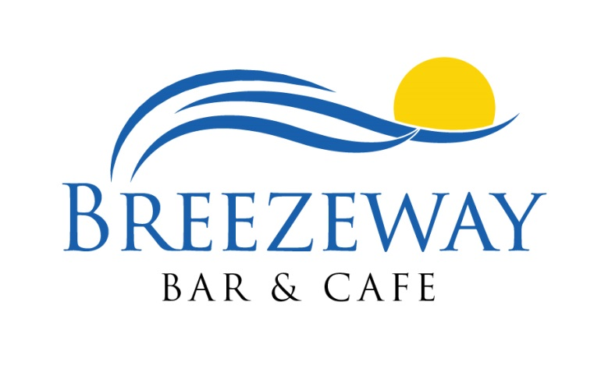
Sweet Treats
Breezeway Krazy Key Lime Bar 7
Meringue, Graham Crust, Tropical Gel

Going Bananas Bar 7
Caramelized Banana, Hazelnut Ganache, Cinnamon Streusel, Chocolate Glaze

Häagen-Dazs Bars 5
Vanilla Almond, Milk Chocolate, or
Chocolate Dark Chocolate

Popsicles
Push Pops 2
Dreamsicles 4

Housemade Gelato & Sorbet 6
Madagascar Vanilla Bean or
Flavors of the Month

BWC Giant “Chocolate Chewie” 3.5

Milkshake 5
Vanilla, Chocolate or Strawberry
Spiked Milkshake 13
Ice Cream Mix, Choice of Liqueur
For the Tadpoles

Grilled American Cheese on White 6

Peanut Butter & Jelly or Banana 6

All Beef Wagyu Hot Dog 7

Classic Cheeseburger 6.5

Kraft Mac-n-Cheese 6

Big Glory Bay Salmon 12

Grilled or Fried Chicken Strips 6.5

Choice of: Shoestring Fries,
Celery & Carrot, Fresh Fruit
Salads
Italian Panini
Shredded Lettuce, Sliced Tomato, Ham, Salami, Pepperoni, Provolone, Italian Herb Aioli…15
Coconut Shrimp
Sweet & Spicy Mango Sauce…10
Southwest Chips & Dips
House Salsa, Chunky Guacamole,
Fresh Tortilla Chips…8
Tuna Tartare Wonton Bites*
Seaweed Salad, Wasabi Mayo, Sesame Seeds, Roasted Garlic, Ponzu…10
Jumbo Chicken Wings
Choice of: Buffalo, BBQ, or
“500” Sauce with Bleu Cheese or Ranch and Celery…13
Soup Du Jour…5.25/7.25
Breezeway Berry Salad
Strawberry, Blueberry, Raspberry,
Orange, Vanilla Almonds,
Artisan Field Greens…10.5/13.5

Thai Chicken Salad
Green Onion, Shredded Carrot,
Daikon Radish, Bean Sprouts,
Napa Cabbage, Basil, Mint, Cilantro,
Thai Peanut Dressing…12.5/15.5

Seared Tuna Nicoise Salad*
Seared Ahi Tuna, Tomatoes, Olives,
Haricot Vert, Onions, Egg, Anchovy,
Herbed Garlic Vinaigrette…12.5/15.5

Salmon & Avocado Salad*
Romaine, Cherry Tomato, Roasted Corn, Nueske Bacon, Cucumber, Scallion,
Green Goddess Dressing…16/19

Alpha D’ Greek Chop Salad
Iceberg, Kalamata Olive, Tomato, Cucumber, Onion, Pepper, Pepperoncini, Feta,
Potato Salad, Greek Vinaigrette…10.5/13.5

Korean Power Bowl
Rice, Black Beans, Cucumber, Spinach, Carrots, Cabbage, Bean Sprouts, Oyster Mushroom, Gochujang Dressing…11/14
Salad Buddies
Grilled Chicken…6.75
Florida Grouper….17
Big Glory Bay King Salmon*…18
Red Snapper…16
Spiced Shrimp (3)…8.5
Seared Tuna*…17
Skirt Steak*...20

Panini

Bourbon Street Shrimp Po-Boy
Crispy Shrimp, Sweet & Spicy Slaw,
House Ripened Tomato, Shaved Lettuce, Creole Remoulade…17
Crispy Pork Panini
Tomato, Slaw, House Made B&B Pickles,
Yellow Mustard…15
Philly Cheese Steak Panini
Thin Sliced Marinated Roast Beef, Caramelized Onions, Yellow & Green Bell Pepper, White American, Provolone…15
Roasted Veggie Club Panini
Grilled Squash, Zucchini, & Portobello, Roasted Red Pepper, Arugula,
Tomato-Goat Cheese Spread…14
Chicken Cordon Bleu Panini
Ham, Swiss, Lettuce, Tomato,
Whole Grain Honey Mustard Spread…15
Reuben Panini
House Shaved Corned Beef, Sauerkraut,
Swiss Cheese, 1000 Island, Marble Rye…15
Bonita Bay “Club” Panini
Boar’s Head Ham and Turkey, Nueske Bacon, Cheddar, Lettuce, Tomato…15
Back Bay Baskets
Açaí Bowls
Bonita Bay Bowl  Granola, Banana,  Blueberry, Raspberry, Coconut, Honey…12 | Coco-Loco  Strawberry, Banana, Coconut, Cacao Nib, Almond, Honey…12 | Avocado Elvis  Avocado, Cacao Nib, Peanut Butter,  Banana, Honey… 12

Fresh Catch Basket
Shoestring Malt Fries, Coleslaw,
Caper Tartar Sauce…MP
Florida Grouper
Shoestring Malt Fries, Coleslaw,
Creole Remoulade…21
Big Glory Bay King Salmon*
Shoestring Malt Fries, Coleslaw,
Teriyaki Sauce…20
Jumbo Shrimp
Shoestring Malt Fries, Coleslaw
Choice of: Cocktail, Mustard or Buffalo…17
Fresh Bay Scallops
Shoestring Malt Fries, Coleslaw,
White Chile Sauce…16
Hand Battered Chicken Tenders
Shoestring Fries, Coleslaw
Choice of: Honey Mustard, BBQ, Buffalo or Ranch…13.5
“Make a WAVE”
Choose any of the above, served grilled or blackened with Petite Salad or Soup
Seafood Feast
Choose Three of our Basket Items to create your own Ultimate Feast
Includes Shoestring Malt Fries, Coleslaw
& Appropriate Sauces…24

Sandwiches and Such

1/2 Pound Bonita Bay Burger*
Custom Ground Brisket and Chuck, Bibb, Beefsteak Tomato, Red Onion, Pickle,
Toasted Kaiser Roll…16

Classic BLT
Bacon, Lettuce, Tomato, Mayo,
Toasted White…12

Poolside Club
Boar’s Head Turkey, Lettuce, Nueske Bacon, Ugly Ripe Tomato, Mango Aioli,
Toasted Challah…14.5

Blackened Gulf Whitefish Tacos
Shredded Red Cabbage, Corn Salsa, Avocado, Cilantro Crème Fraiche,
Lime Wedge…16

Southwestern Pulled Chicken Wrap
Romaine, Black Beans, Avocado,
Corn, Red Onion, Tomato,
Roasted Red Pepper Aioli…14

All Sandwiches come with choice of:
Italian Herb Fresh Potato Chips Sweet Potato Fries Sidewinders Shoestring Fries Truffle Fries (+$2) Fruit Chopped Apple Coleslaw

Scott Whidden CSC, Breezeway Chef de Cuisine
BBCulinary Team
*Consuming raw or undercooked meats, poultry, seafood, shellfish, or eggs may increase your risk of food borne illnesses
Denotes healthy selections

