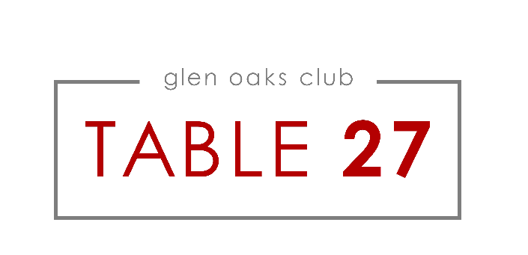
Appetizers
Smoked Lamb Chops
Cucumber Salad,
Mint-Yogurt Sauce -17

Tomato Salad
Bacon, Watermelon
Mustard Dressing -15

Lobster Tacos
Avocado, Lime Crema -17

Tuna Tartare
White Miso, Avocado,
Potato Chips -19

Baby Gem Lettuce
Grapes, Cucumber, Radishes, Walnuts,
Lime Dressing -15

Crab Cake Sliders
Mango Tartar Sauce, Lettuce, Tomato -17

Crispy Beau Soleil Oysters
Dill Cream, Imperial Caviar -19

Chilled or Hot
Citrus Scented Tomato Soup
Burrata & Basil Toast -15

Entrées
Charred Romaine Lettuce
Roasted Cherry Tomatoes,
Lemon Marinated Mushrooms,
Shaved Parmesan
Creamy Shallot Dressing
Choice: Salmon, Shrimp, Chicken or Steak -28

Grilled Dover Sole
Spinach, Mustard & Yuzu Hollandaise -45
Seared Salmon and Scallops
Cherry Tomatoes, Dill-Mussel Broth -39

Wagyu Skirt Steak
Smoked Caramelized Onions,
Shaved Brussels Sprouts,
Choron Sauce -45

Tuna Sashimi
Crispy Rice,
Avocado, Pineapple Salsa -27
Fresh Linguini
Chanterelles, Pistachio Pesto, Lemon, Parmesan -34
Herb Roasted Chicken
Orange Roasted Carrots,
Mushroom & Marsala Sauce -27
T27 Burger
Tomato Jam, Lettuce,
Clothbound Cheddar,
Sweet Onion -26

Sides
Served Family Style!

Hand Cut Fries
Grilled Corn, Lime
Roasted Asparagus
Roasted Hen of the Woods Mushrooms

