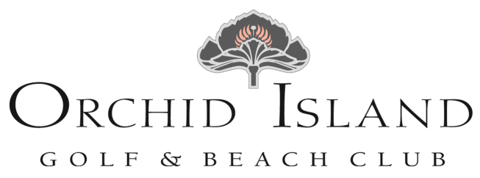

Golf Club Dinner Menu
Tuesday, February 1, 2022

SOUPS & STARTERS

Beef & Toasted Barley Soup $7/$9

Chilled Gazpacho $7/$9
Cilantro & Scallions

Charred Octopus & Chinese Broccoli $14
Nori Mayonnaise

Prosciutto with Roasted Figs & Brie Cheese $14
Baby Kale & Honey

Heirloom Tomato & Burrata Salad $14
Red Watercress & Arugula Pesto

Roasted Beet & Baby Arugula Salad $12
Grapes, Goat Cheese, Candied Pecans
Apple Cider Vinaigrette

SHARABLES

Baby Squash & Asparagus “Fries” $12
Green Goddess Dressing

Sesame Seared Yellowfin Tuna $21
Wasabi, Pickled Ginger & Shoyu

Crispy Calamari $14
Marinara & Tartar Sauce

Charcuterie & Crudité $14

Iced “Moon Rise” Oysters $3ea.
Cucumber Mignonette & Cocktail Sauce

PIZZA & FLATBREAD

Build Your Own Pizza OR Flatbread $14
Mushrooms, Spinach, Onions, Castelvetrano Olives
Tomatoes, Roasted Peppers, Tomato Sauce, Pesto
Pepperoni, Italian Sausage, Chicken, Mozzarella & Fontina

*Consuming raw or undercooked meats, poultry, seafood, oysters or eggs may increase
your risk of food borne illness, especially if you have certain medical conditions.

SALADS & PASTA

Chilled Red Shrimp Salad, Cucumber Herb Salsa $21
Quinoa Tabouleh

Smoked Salmon Salad, Sherry Mustard Vinaigrette $20
B&W Watercress, Asparagus, Kohlrabi, Fennel, Citrus

Grilled Chicken Paillard, Amarillo Pepper Dressing $19
Tomatoes, Radish, Turnips, Green Beans, Squash, Okra

Potato Gnocchi, Red Wine Braised Veal $16/$24
Wilted Swiss Chard, Roasted Tomatoes & Fontina Cheese

FISH & SHELLFISH

Grilled Wahoo, Lemon Butter Sauce $32
Spaghetti Squash, Wilted Local Kale

Sautéed Dolphin, Tomato Pistou $30
White Bean & Vegetable Stew

Teriyaki Glazed Salmon, Sesame & Scallions $32
Warm Rice Noodle & Vegetable Salad

Pan Roasted Sea Scallops, Squash Blossom Aioli $34
Watercress Potatoes & Swiss Chard

POULTRY, LAMB, VEAL, & BEEF

Herb Roasted Half Chicken, Cranberry Sauce $27
Local Squash, Green Beans & Golden Potato Purée

Braised Lamb Leg Stew, Gremolata $28
Asparagus & Polenta Corn Cake

Sautéed Veal Cutlet, Lemon Caper Brown Butter $33
Local Squash, Green Beans & Rice Pilaf

Grilled Prime Flat Iron Steak, Mushroom Sauce $36
Local Squash, Green Beans & Golden Potato Purée

Grilled 10oz. Ribeye Steak, Béarnaise Sauce $39
Local Squash, Green Beans & Golden Potato Purée

*Consuming raw or undercooked meats, poultry, seafood, oysters or eggs may increase
your risk of food borne illness, especially if you have certain medical conditions.

