OLD OAKS
COUNTRY CLUB
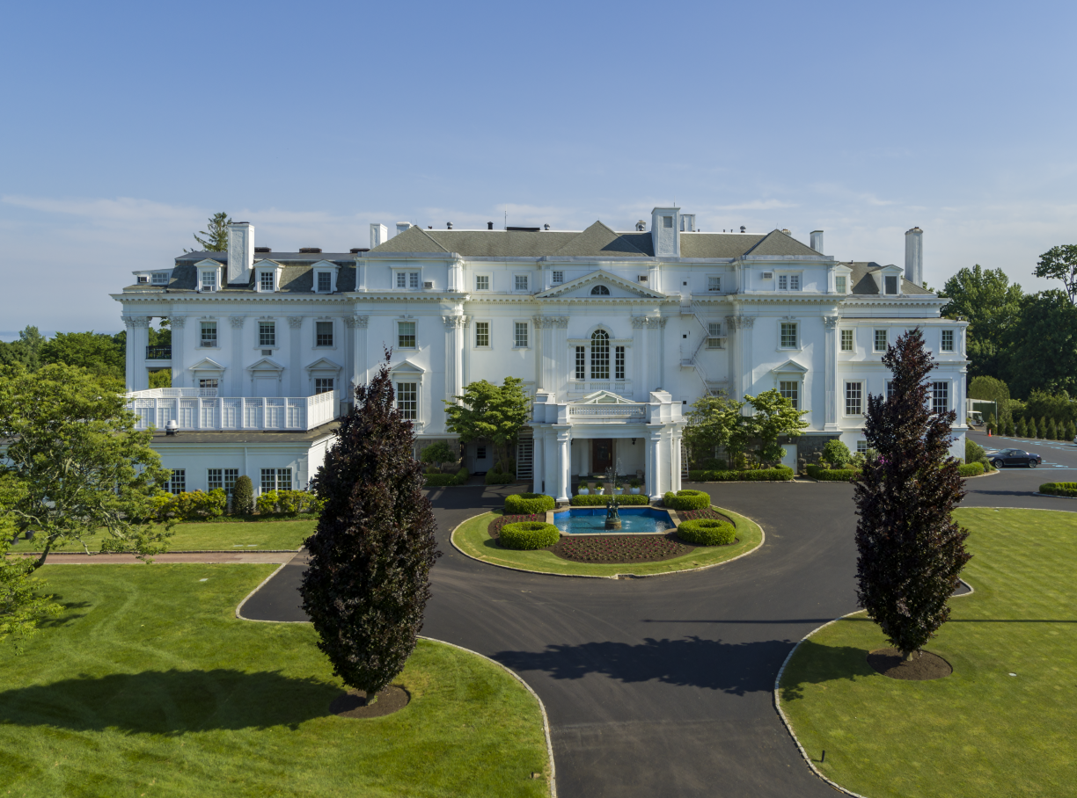CATERING MENU

Old Oaks Country Club, 3100 Purchase Street, Purchase, NY 10577
(914) 683-6000

HORS D’ OEUVRES
PASSED BUTLER STYLE (select eight)

COLD
avocado toast bites, pickled radish, peppercorn aioli (v)
salmon tartare, rice cracker, lemon dill crema (GF)
blini with caviar and crème fraiche
Thai summer roll, soy ginger sauce (v)
smoked salmon on blini with caviar and crème fraiche
caprese salad pops, balsamic glaze (v, GF)
watermelon poke, yuzu mint marmalade, rice cracker, sesame seeds (v, GF)
petit tomato bruschetta (v)
jumbo shrimp cocktail (GF)
mini crab salad taco, tomato, avocado
chilled gazpacho shots, crispy tortillas (v)
spicy tuna tartare and avocado in sesame waffle cone
mini lobster rolls

HOT
Thai chicken saté, peanut sauce
truffle potato pancakes, NY applesauce
jumbo lump crab cakes, sriracha aioli
wild mushroom and truffle in phyllo
fig and brie in phyllo
coconut shrimp, sweet chili sauce
herb marinated baby lamb chops, mint marmalade
turkey pot stickers, soy ginger sauce
chicken lemongrass pot stickers, soy ginger sauce
vegetable pot stickers, soy ginger sauce,
vegetable spring rolls, soy dipping sauce
shrimp and vegetable shumai, ponzu sauce
artichoke and goat cheese beignets
mini grilled cheese and tomato soup
mini beef sliders, ketchup
mini franks in a blanket, mustard
scallops wrapped in bacon, citrus aioli
chicken quesadilla, roasted tomato salsa
chicken and waffle with spicy maple syrup

v = vegetarian
GF = gluten free
STANDARD STATIONS
DISPLAYS

TUSCAN MARKET ANTIPASTO TABLE

thinly sliced assorted salamis and imported prosciutto, long stem artichokes, roasted peppers, pickled vegetables and assorted olives, breadsticks, hummus and toasted pita

MEDITERRANEAN TABLE
marinated and grilled vegetable display, marinated artichoke hearts, roasted mushrooms, assorted olives in extra virgin olive oil, heirloom tomatoes, fire roasted sweet peppers, whipped ricotta with basil, roasted garlic hummus, pita breadsticks and artisan bread

INTERNATIONAL CHEESE AND CRUDITÈ TABLE
garden fresh variety of seasonal vegetables with assorted dipping sauces, assortment of domestic and international cheeses, basket of imported crackers and flatbreads

PIZZA AND FLATBREAD STATION
select three:
pizza margherita
pepperoni pizza
grilled vegetable and provolone
white pizza with broccoli, garlic and ricotta
sriracha chicken with bleu cheese and bacon
asparagus, prosciutto and provolone

STANDARD STATIONS
ACTION (select any three standard stations with attendant)

PEKING DUCK WRAPPED TO ORDER
marinated Peking duck wrapped in moo shoo pancakes, with cucumber, scallions and hoisin sauce

ITALIAN PASTA STATION
(select two pastas & three sauces)
PASTAS: penne, rigatoni, orecchiette, gluten free penne
with Chef’s selection of toppings
SAUCES: marinara, alfredo, a la vodka, bolognaise, garlic and oil
with basket of garlic bread

STREET TACO STATION
(select two)
grass fed beef, spicy chipotle chicken, pulled pork or Baja fish
with flour and corn tortillas, salsa, guacamole, Pico de Gallo, sour cream, shredded lettuce, tomatoes, red onions, cilantro, Monterey jack cheese, jalapeños and tortilla chips

ALL AMERICAN SLIDER STATION
(select two)
griddled to order: beef, turkey, salmon or veggie
with lettuce, tomatoes, onions, pickles, sautéed mushrooms, American cheese, cheddar cheese, mini soft rolls
French fries or sweet potato fries

POKÉ BOWL STATION
(select two of each)
MAIN: ahi tuna, salmon, shrimp, spicy chicken, tofu
FILL: basmati rice, brown rice, quinoa
with cilantro, cucumber, mango, edamame, kale, red onion, seaweed, avocado, scallions, pickled ginger, kimchi, wasabi tobiko, crispy onions, sesame seeds, chow mein noodles, ponzu dressing, ginger dressing, sriracha aioli, sweet chili sauce

ASIAN STIR FRY STATION
(select two)
chicken, beef or shrimp stir fry with Asian vegetables, teriyaki sauce and stir fry rice
PREMIUM STATIONS

CAVIAR AND FROZEN VODKA STATION (with attendant)
American caviar, toast points and blinis, crème fraiche, red onions, chives and chopped eggs

SEAFOOD MARTINI STATION (with attendant)
shrimp, crab and salmon
shredded lettuce, tomatoes, tricolor peppers, jicama, avocado, cucumber, basil, cilantro and dill, sauce vert, cocktail sauce and Russian dressing

FRESH CHILLED SEAFOOD BAR
iced jumbo shrimp, top neck clams and blue point oysters on the half shell
garnished with lemons, horseradish and cocktail sauce, mignonette

SUSHI STATION (with attendant)
authentic sushi chefs preparing an assortment of freshly made sashimi, sushi and assorted rolls
soy sauce, wasabi and ginger

MARYLAND CRAB CAKE STATION (with attendant)
jumbo lump crab cakes sauteed to order, accompanied by an assortment of dipping sauces

CHEF’S GOURMET ANTIPASTO DISPLAY
Featuring a selection of gourmet cured meats, international cheeses, roasted vegetables, pickled vegetables, olives, whipped cheese, hummus, crackers, breads, dips and fruits

INDIVIDUAL CARVING STATIONS (with attendant)
roast tenderloin of beef, béarnaise sauce
freshly roasted whole turkey or turkey breast, natural jus and cranberry relish
roasted rack of New Zealand lamb, fresh mint marmalade
marinated NY sirloin, demi-glace

DINNER
FIRST COURSE (select one)

HEIRLOOM TOMATO and BUFFALO MOZZARELLA
aged balsamic vinaigrette

THE CLASSIC CAESAR
crisp romaine, sourdough croutons, Reggiano parmigiana, Caesar dressing

BABY ARUGULA and ROASTED GOLDEN BEET SALAD
feta cheese, toasted cashews, sherry vinaigrette

BABY KALE and FRISÉE SALAD
sliced granny smith apples, toasted almonds, dried cranberries, white balsamic vinaigrette

MESCLUN GREENS and ROASTED PEAR SALAD
candied pecans, dried cranberries, goat cheese, roasted pear vinaigrette

OLD OAKS ROASTED VEGETABLE SALAD
butternut squash, zucchini, yellow squash, carrots, golden beets, parsnips, haricot vert, asparagus tips, feta cheese, lemon vinaigrette, micro greens

AHI TUNA TARTARE
seaweed salad, avocado, sriracha soy dressing

BURRATA SALAD
sliced heirloom tomatoes, balsamic pearls, basil

WILD MUSHROOM RISOTTO or TRUFFLE RISOTTO
shaved Reggiano parmigiana

TRIO SALAD
Caesar wedge, parmesan croutons; petite caprese salad, balsamic glaze; roasted vegetable salad

DINNER
ENTRÉE (select two)

SEAFOOD
SEARED BRONZINO FILLET
eggplant caponata

MISO GLAZED CHILEAN SEA BASS
Asian pear relish

SEARED RED SNAPPER
cilantro lime butter

GRILLED TERIYAKI GLAZED SALMON
seaweed salad

GRILLED SWORDFISH
roasted tomato relish

CHICKEN
CHICKEN MILANSE
arugula, radicchio, red and yellow tomatoes, balsamic vinaigrette

FRENCH CUT BREAST OF CHICKEN
lemon and garlic marinated, lemon herb beurre blanc

BREAST OF CHICKEN FRANCAISE
lemon wine and butter sauce
MEAT
PRIME NEW YORK SIRLOIN STEAK
shallot red wine demi-glace

PAN SEARED FILET MIGNON
wild mushroom demi-glace

24 HOUR BRAISED BEEF SHORT RIB
pan jus

SLICED TENDERLOIN OF BEEF
red wine truffle sauce, crispy onions

TRADITIONAL OLD OAKS RACK OF AUSTRALIAN LAMB
mint demi-glace

GRILLED VEAL RIB CHOP
port wine demi-glace

SIDES AND ACCOMPANIMENTS
haricot vert with lemon butter
roasted baby carrots
sautéed spinach
garlic scented broccolini
roasted baby squash
roasted potatoes
garlic whipped potatoes
seasonal risotto
basmati rice
saffron scented Israeli couscous
DINNER
DESSERTS

DESSERT – PLATED (select one)
MOLTEN CHOCOLATE LAVA CAKE
Tahitian vanilla ice cream, crème anglaise, pirouline cookie crisp

FRESH FRUIT AND SEASONAL BERRIES
whipped cream, raspberry coulis

LEMON MERINGUE PIE
seasonal berries, whipped cream, raspberry coulis

INDIVIDUAL APPLE TART
cinnamon ice cream, caramel and vanilla sauces

INDIVIDUAL KEY LIME PIE
whipped cream, fresh raspberries

-OR-

PASSED TREATS (select five)
CHEESECAKE POPS

CHOCOLATE DIPPED STRAWBERRIES

RICE KRISPIE TREATS

FUDGE BROWNIE BITES

MINI CHIPWICH

CHURRO BITES WITH CHOCOLATE SAUCE

DONUT HOLES WITH CARAMEL SAUCE

CHOCOLATE MOUSSE CUPS

ASSORTED PETIT FOURS

FRENCH MACAROONS
DINNER
DESSERT ENHANCEMENTS

MAKE YOUR OWN SUNDAE BAR
ICE CREAM: vanilla, chocolate, strawberry, coffee, oreo bomb
TOPPINGS: oreo cookie crumbs, mini M&Ms, jellybeans, gummy bears, sprinkles, hot fudge, caramel sauce

OLD OAKS COOKIE STATION
assorted freshly baked jumbo cookies: chocolate chip, triple chocolate chunk, oatmeal raisin, gluten free chocolate chip cookies
shots of milk
add ring dings, ho-ho’s and twinkies

Cake plating and fruit plates included in package
All dinners served with freshly brewed regular and decaffeinated coffee and Old Oaks tea selection

