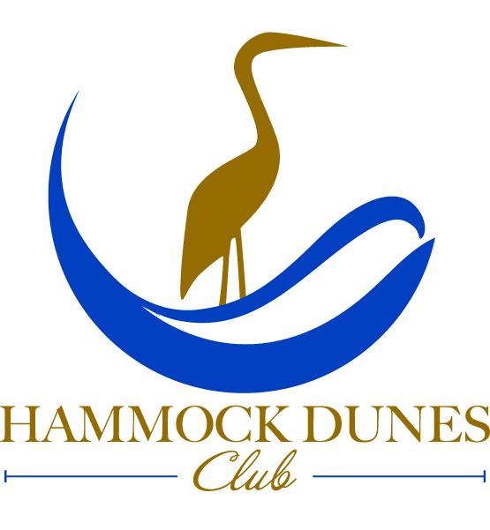

Hammock Dunes Club
SEASIDE Dinner Menu

SOUPS

Roasted Chicken Consommé
foraged mushrooms, thinly sliced chives
cup 8 / bowl 10

Celeriac-Carrot
dried apple bits, sunflower seed powder, celery leaf creme
cup 7 / bowl 9

Soup of the Evening
prepared fresh daily by our culinary staff
cup 5 / bowl 7

SALADS

Hydroponic Bibb Lettuce
orange segments, red onions, toasted almonds, crumbled goat cheese, grapefruit-poppy seed dressing 8

Arugula-Spinach Blend
pickled beets and green beans, chopped eggs, fried onions, creamy honey-mustard bacon dressing 7

Classical Caesar
crisp romaine coated with classical dressing, herbed croutons, grated parmesan, shaved asiago, tomato jam
white or dark anchovies optional / small 5 / entrée 7

Baby Kale-Rainbow Quinoa Bowl
Topped with: maple roasted butternut cubes, dried cranberries, crumbled bleu cheese,
walnuts, bacon pieces, sherry-lemon dressing 12.5
Additional protein: chicken 5 / shrimp (6) 10 / salmon (6oz) 12 (blackened, grilled, jerk spiced, seared, bronzed)

TAPAS
Tempura Asparagus
spiced teriyaki glaze, sesame seeds, tri pepper curls 7.5

Jumbo Shrimp Cocktail (6)
horseradish cocktail sauce, cucumber wrap, lemon 11

Bacon Fried Apples (3)
thyme-brie béchamel, caramelized vidalia onions,
pickled mustard seeds 9

Fresh Made Herbed Pasta
crumbled feta cheese, toasted pine nuts, cured tomatoes, lemon butter, garlic chips 8.5

HANDHELDS
accompanied with choice of side item

Vegetable Tacos
warm flour tortillas, chipotle coated black beans with griddled zucchini-yellow squash-bell peppers-red onions in garlic-cilantro-cumin, lettuce shred, sour cream dollops, green onions; tomato salsa side 12.5

* Horseradish Burger
mushroom-fire roasted red pepper ragout, melted provolone cheese, horseradish aioli, eight ounces of grass fed ground beef, toasted brioche bun, fully dressed 13

ENTRÉES
(Entrees include listed accompaniments and vegetable of the evening; seafood/vegetarian side is featured rice; meat side is mash of the evening
additional sides $4)

Butternut Squash Wellington
mushroom-shallot duxelle, herbed hollandaise 19

Wild Caught Catch
changed daily, white wine-shallot beurre blanc 25

Veal Scallopini
dredged, pan fried, white wine-butter-caper sauce, charred thick cut lemons 24

Ginger Glazed Mahi
pineapple-soy-lime seared, quick pickled red onion 22

* Certain items are served raw or cooked to order. Consuming raw or undercooked shellfish or meat may increase your risk of food-borne illness. Especially if you have certain medical conditions.

* Herb de Provence Lamb Rack
marinated and grilled, mint scented glace 28

Goat Cheese-Leek Filo Strudel
with red peppers-spinach, carrot puree 18

* Filet Mignon
chargrilled, bacon-onion marmalade, red wine syrup
six ounce 33 / eight ounce 40

Panko Crusted Crab Cakes
creole remoulade, tomato-lemon jam 24

Please let us know if you have any special dietary needs or allergies when ordering. Requests: if we have the ingredients we want to make it for you. Please inquire with your server.

Dinner Menu available: Tues-Sun 5pm-9pm / Executive Chef: Lance S Cook, WCMC, CEC, CCA, CFBE, FMP, CFSM

11.2020

