The Club at Carlton Woods
Plated Lunch Menus

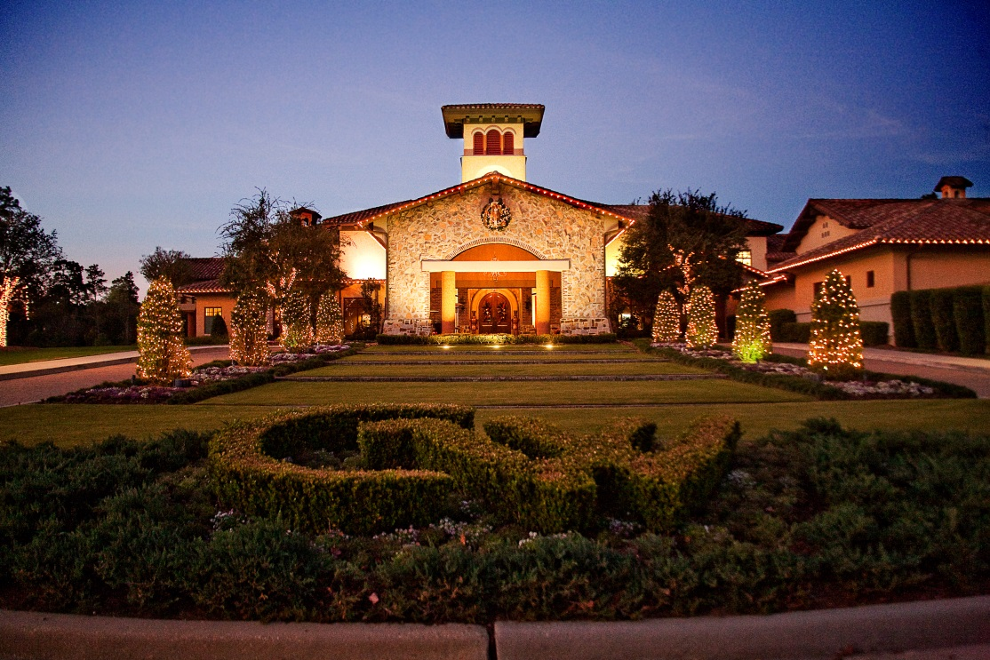

Plated Lunch Selections
All lunches come with Coffee, Decaffeinated Coffee and Iced Tea

Salad Selections
Mixed Field Greens Salad
Demi Sec Tomatoes, Julienne Carrots, Cucumbers, Candied Pecans, Balsamic Vinaigrette
$10

Classic Caesar Salad
Baby Romaine, Parmesan Crisp, Demi Sec Tomatoes, Kalamata Olives, Garlic Croutons, Caesar Dressing
$12

Roast Beet & Arugula Rocket Salad
Crumbled Farmers Feta, Candied Pecans, Citrus Vinaigrette
$13

Autumn Pomegranate Salad
Baby Aquaponics Greens, Spiced Butternut Squash, Crumbled Bleu Chese, Smoked Bacon Lardons, Pomegranate Vinaigrette
$14

Seafood Selections
Mairtre D’ Broiled Halibut Pave
Grilled Asparagus, Grape Tomatoes Confit, Lemon Thyme and Saffron Scented Risotto
Piquillo Coulis
$42

Cajun Blackened Chilean Sea Bass
Sautéed Spinach and Red Peppers, Ratatouille, Whipped Garlic & Rosemary Potatoes, Orange Caper Butter
$46

Pistachio Crusted Diver Scallops
Glazed Carrot Nage, Haricot Verts, Herb Roasted Fingerlings, Pernod Beurre
$38
Beef & Pork Selections
Tournedos of Beef (7 oz)
Sautéed Filet Mignon, Charred Broccoli, Carrot-Parsnip Haché, Aged Cheddar Potato Cake,
Bordelaise Sauce
$48

Allen Brother’s Prime Ribeye (16 oz)
Flame-Grilled Ribeye, Tabacco Onions, Roasted Sweet Chili Brussels, Loaded Baked Potato
Maitre D’ Butter
$46

“Sous Vide” Kurobuta Pork Chop
Cinnamon Apple & Butternut Squash Puree, Roasted Asparagus, Herbed Cheddar Polenta Cake,
Port Demi-Glace
$42

Poultry Selections
Chicken Scallopini
Pan Fried Chicken Breast Cutlet, Whipped Potatoes, Grilled Lemon Pepper Asparagus, Beurre Blanc
$28

Boursin Stuffed Airline Breast of Chicken
Springer Mountain Farms’ Airline Chicken Breast, Roasted Seasonal Roots & Potatoes,
Whole Grain Mustard Pan Gravy
$32

Greek Chicken
Feta, Dried Tomato and Pignoli Stuffed Breast, Sautéed Spinach
Roasted Lemon Thyme Fingerling Potatoes, Tzatziki
$30

Pan Seared Muscovy Duck Magret
Baby Green Beans, Roasted Sweet Potatoes, Black Pepper Pappardelle
Forestiere Sauce
$36

Supreme of Chicken Chasseur
Grilled Green Asparagus, Dried Tomato-Pancetta Risotto
Mushroom-Truffle Sauce
$32

Vegetarian Selections
Roasted Cabbage Steak
Winter Squash Nage, Micro Salad, Crispy Papadums, Ravigote Sauce
$28

Apple-Ginger Glazed Butternut Squash
Braised Red Cabbage, Grilled Asparagus and Spicy Pecans
$28

Dessert Selections
Carlton Woods Crème Brûlée
Classic Vanilla Custard, Fresh Berries
$12

Fresh Fruit Tart
Fresh Fruit topped with Apricot Glaze in a Pastry Filled Crust
$10

Seasonal Bread Pudding
Vanilla Custard Anglaise, Fresh Berries, Gelato
$12

Seasonal Fresh Berries
House Made Sorbet
$8

Chocolate Ganache
Chantilly Cream, Candied Orange Zest, Bing Cherries
$12

