– April 30th – May 20th -
Bar Snacks & Pub Fare
- Rosemary & Sea Salt Roasted Almonds -6-

- 3-Hawaiian Roll BBQ Sliders, Collard-Apple Slaw, Pickle, Blueberry BBQ Sauce -12-

- Black Pepper Pimento Hush Puppies, Pepper Jelly Crema -8-

- Crispy Pickled Lamb Belly, Carolina Gold Rice Salad, Smoked Tomato Aioli, Buttered Saltines

-12-

- Cheese & Olive Plate, (choices change regularly)
Marinated Olives, Quince Paste, Grilled Stick Boy Bread - 1 cheese -12-/ 2 cheeses -15-/ 3 Cheeses -18-

- *8 – Smoked Chicken Wings, Celery, Tomato Jam, Maytag Blue Cheese Dipping Sauce (Also Available Traditional Style, BBQ or Dry Rub) -9-

- *Brisket Burger, Brioche Bun, Lettuce, Tomato, Onion, Choice of Side -10-

- House Made Flat Bread, Marinara, Mozzarella, Herbs, Pepperoni -12-

- *Duck Burger, Smoked Gouda, Tomato Jam, Brioche Bun, Lettuce, Tomato, Onion, One Side
-16-
Facebook@????
Instagram@?????

Appetizers & Salads

- *Seared Monkfish Medallions, Chilled Fingerling Potato Salad, Bubbling Chorizo Butter -14-

- *Pimento Cheese & Pickles, House Made Buttered Saltines, Good Night Bros Ham -10-

- * Tomato Soup, Grilled Cheddar Cheese Crostini, Watercress -8-

- *Shrimp Cocktail, Caper-Lemon Aioli, Heirloom Cocktail, House Made Buttered Saltines -10-

- *Spring Lamb Loin, Sauteed Morels, Ramps, Watercress, Toasted Pecan, Chevre Cream -13-

- Shulls Mill Salad, Charlottes Greenhouse Lettuce, Grape Tomatoes, Cucumbers, Crumbled Goat Cheese, Pine Nuts, Raspberry Vinaigrette
-Small 6 Large 8-

- Caesar Salad, Crisp Romaine Lettuce, Focaccia Croutons, Parmesan Cheese, Anchovies, Caesar Dressing -Small 7 Large 9-

- Arugula & Compressed Melon Salad
Feta Cheese, Spiced Pecans, White Balsamic Vinaigrette -10-

More info sharing????

Pastas & Entrée’s
- Beef Bolognese, Parmesan, Basil, Bucatini Pasta
-17-

- Veal Scallopini Parmesan, Lemon-Caper Butter, Tomato, Basil, Parsley, Angel Hair -24-

- *Seared Scallops, Black Pepper-Lemon Cream, Asparagus, Tomato, Sweet Peppers, Garlic, Parmesan, Oregano, Fettuccine -26

- Saltine Baked Sunburst Trout, Mountain Ratatouille, Ramp & Mint Consommé
-23-

- *File’ Blackened Pork Ribeye, Dirty Rice, Pickled Sweet Peppers, Caramelized Okra, Sauce Bearnaise -24-

- *Lemongrass Steamed Golden Tilefish, Sesame Bok Choy, Shiitake Mushrooms, Radish, Miso-Tamari Emulsion -27- -

Entrée’s & Pasta’s

- *Grilled 6OZ Beef Tenderloin or 12OZ Ribeye, Yukon Gold Potato Puree, Grilled Asparagus & Broccolini, King Trumpet Mushrooms, Red Wine Sauce -27-
,

- *Chicken Schnitzel, Roasted Cauliflower, Heirloom Carrots, Lemon, Pine Nuts, Parsley, Caper-Bacon Vinaigrette -18-

Desserts
- Hound Ears Pie, Vanilla Ice Cream, Graham Cracker Crust, Warm Fudge -1/2 Slice – 5-
-Full Slice -10-

- House Made Carrot Cake, Vanilla Cream Cheese Icing, Ginger Ice Cream -8-

- Mango Custard, Green Tea Marshmallow, Cashew Sponge
-9-

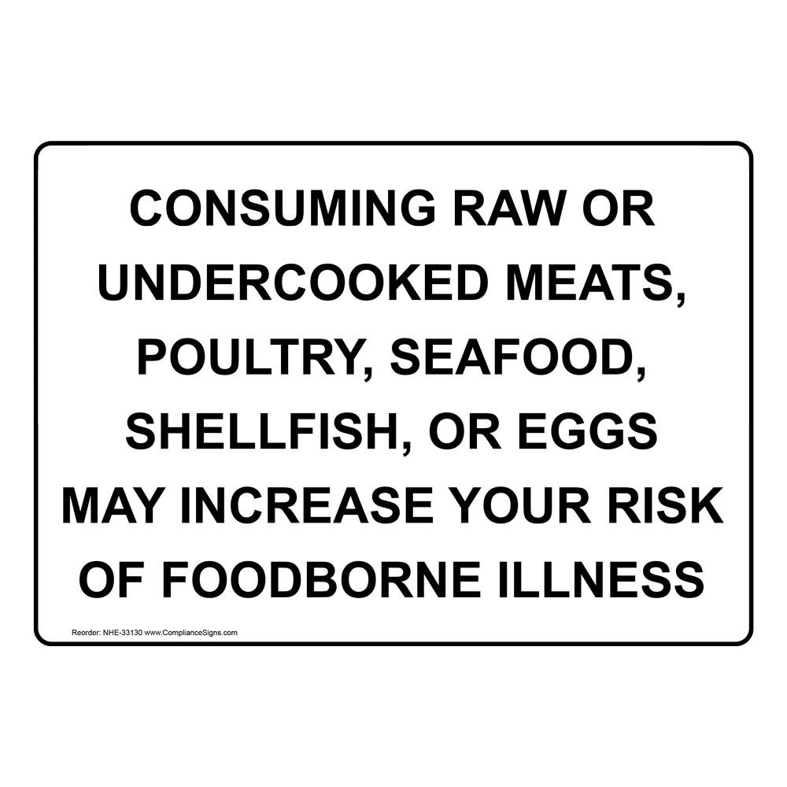

Beer
Bud Light, Budweiser, Coors Light, Michelob Ultra, Miller Lite
3.50

Beck’s NA, Blue Moon, Corona Premier, Fat Tire, Sierra Nevada Pale, Stella Artois, AMB Gold Medal Lager
4.50

AMB Longleaf IPA, Guinness, Bell’s Light Hearted,
Fonta Flora Carolina Gold,
5.50

Ask your server about our rotating draft beer selection

Cocktails
Cocktail 1
Ingredients
Price

Cocktail 2
Ingredients
Price

Cocktail 3
Ingredients
Price

Cocktail 4
Ingredients
Price

Cocktail 5
Ingredients
Price

Chardonnay
500 Alias California 2018 7/26
501 Brocard ‘Kimméridgien’ Burgundy, France 2019 9/34
502 Sonoma-Cutrer Sonoma Coast, California 2019 11/42
503 Moffett Chardonnay Willamette Valley, Oregon 2018 45
504 Frank Family Carneros, California 2017 45
505 Domaine Gerbeaux Pouilly-Fuisse, France 2017 55
506 Louis Moreau 1er Cru Chablis, France 2018 60
507 Revelry Unoaked Columbia Valley, Washington 2018 35
508 Sylvaine & Alain Macon La Roche Vineuse, France 2017 50
509 Vincent Girardin Burgundy, France 2018 45
510 Michel & Fils Grand Cru Chablis, France (375mL) 2018 50

Sauvignon Blanc
O&T ‘Les Gourmets’ Touraine, FR 8/30
Huia Marlborough, NZ 10/38
Attitude Loire Valley, FR 35
Kim Crawford Marlborough, NZ 35
Cloudy Bay Marlborough, NZ 50

Pinot Grigio/Pinot Gris/Pinot Blanc
Alto Livello Pinot Grigio Umbria, IT 8/30
Paul Blanck Pinot Gris Alsace, FR 35
St. Innocent Pinot Blanc Willamette Valley, OR 40
Hofstatter Pinot Grigio Alto Adige, IT 45
Santa Margherita Pinot Grigio Valdadige, IT 55

Other White Wines
Shine Riesling Rheinhessen, Germany 7/26
Garzon Albarino Uruguay 8/30*
Jekel Riesling Monterey, CA 25
Ravines ‘Dry’ Riesling Finger Lakes, NY 35
Domaine Salmon Muscadet, FR 30*
Bestheim Gewürztraminer Alsace, FR 35
St. Roch Côtes du Roussillon, FR 35

Sparkling Wine
Ca’ Furlan Prosecco Veneto, IT 8/30
Albert Bichot Brut Rosé Burgundy, FR 45
Tribaut Brut Champagne, FR (375 mL) 40
Tribaut Brut Champagne, FR 70
Tribaut Brut Rosé Champagne, FR 70
Tribaut Blanc de Chardonnay Champagne, FR 70
Veuve Clicquot Brut Champagne, FR 95
Tribaut ’Authentique’ 2009 Champagne, FR 150
Dom Perignon Brut 2006 Champagne, FR 190

Rosé
Elicio Méditerranée, FR 8/30
Block & Tackle California 30

Cabernet Sauvignon
Vina Robles California 8/30
Daou Paso Robles, CA 10/38
Ely Reserve Napa Valley, CA 11/42
Carneros Springs Napa Valley, CA 50
Sinegal Napa Valley, CA 110
Chateau Montelena Napa Valley, CA 85
Caymus Napa Valley, CA 130
Pinot Noir
LOLA North Coast, CA 8/30
Anne Amie Willamette Valley, OR 11/42
Sea Smoke ‘Southing’ Santa Rita Hills, CA 120
Lady Hill Willamette Valley, OR 50*
Fiddlehead ‘Lollapalooza’ Santa Rita Hills, CA 95
Flowers Sonoma Coast, CA 85
Belle Glos ‘Eulenloch’ Napa Valley, CA 75
Moffett Willamette Valley, OR 65
Benjamin Leroux Burgundy, FR 60

Red Blends
Domaine St. Rose ‘La Garrigue’ Languedoc, FR 8/30
X Winery ‘Big Gun Red’ California 30
Opus One Napa Valley, CA 450
Bocelli Tenor Red Toscana, IT 40
Capture ‘Innovant’ Alexander Valley, CA 85
Pas de L’Ane Grand Cru Saint-Emilion, FR 95
Chateaumar Chateaunneuf-du-Pape, FR 65
Casa La Rad ‘Solarce’ Rioja, SP 35
Vega Escal Priorat, SP 45
Vina Otano Reserva Rioja, SP 55*
Leviathan California 60
Continuum Oakville, CA 250
Worthy ‘Sophia’s Cuvee’ Napa Valley, CA 65
Purple Angel Colchagua Valley, CH 115

Other Red Wines
Cholila Ranch Malbec Patagonia, Argentina 8/30
Painted Fields Zinfandel Sierra Foothills, CA 30
Brick Mason Zinfandel Lodi, CA 35
Old Ghost Old Vine Zinfandel Lodi, CA 65
Catena ‘Alta’ Malbec Mendoza, AR 75
Flora Springs Merlot Napa Valley, CA 60
San Roman Toro, SP 85
La Carlina Barbera d’Asti, IT 40
Ginestraia Riserva Chianti, IT 35
Seghesio Barolo, IT 60
Moccagatta Barbaresco, IT 75
Yangarra Shiraz McLaren Vale, AU 35
Mettler Petite Sirah Lodi, CA 45
Max Reserva Carmenere Aconcagua Valley, CH 30

