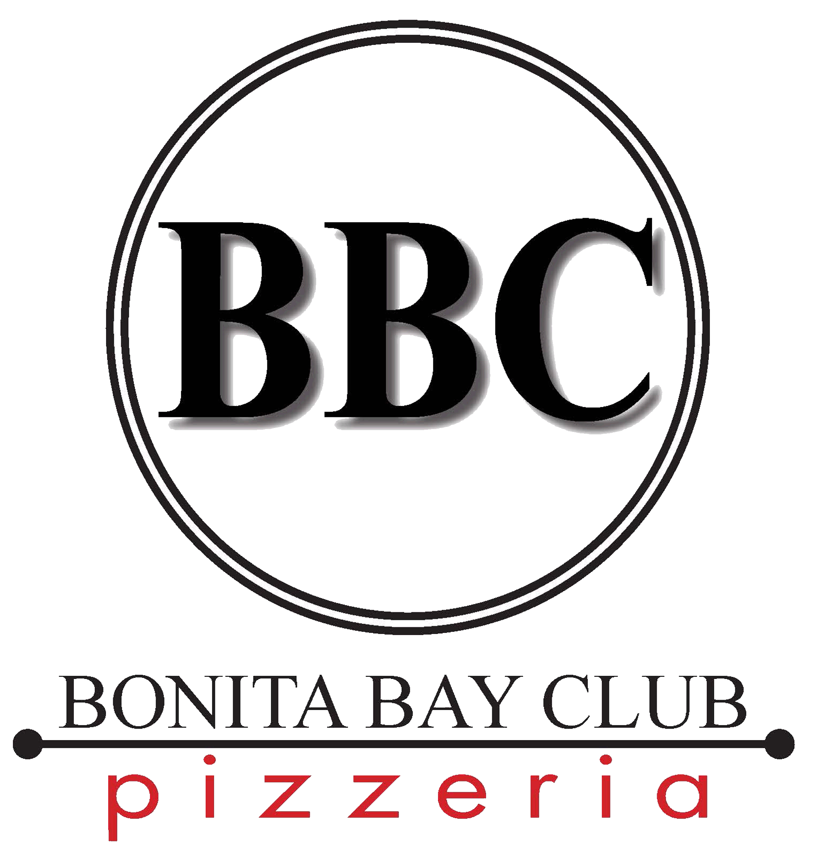
Available During Clubroom Dining Hours

Call 949-5010

All Pizzas are served on a hand tossed thin crust
Choice of Small (10”) or Large (14”)

Choice of Cut: Midwest Style (Squares) or New York Style (Pie)

House Specialties… 14.5/17.5
Weekly Inspiration
Ask your server about this week’s creation

Spinach & Artichoke Pie
Spinach, Artichoke Heart, White Sauce, Mozzarella

Country Bob’s BBQ Chicken
Grilled Chicken Breast, Nueske Bacon, Red Onion, Mozzarella

Signature Six Cheese
Red Sauce, Parsley

Buffalo Chicken
“Red Hot” Chicken, Creamy Ranch, Red Onion, Maytag Bleu

Margherita
Garlic, Basil, Roma Tomato, Fresh Mozzarella, XVOO

El Mariachi
Nueske Bacon, Hot Italian Sausage, Pepperoni, Ham, Hard Salami, Jalapeno, Red Sauce

Simply Cheese…12/15
Add your toppings to make your Signature creation!

Toppings…2/2.5
Extra Cheese, Home-Made Pepperoni, Home-Made Hot Italian Sausage,
Canadian Bacon, Nueske Bacon, Grilled Chicken Breast, Greek Olives, Spanish Onion, Roasted Pepper, Bell Pepper Medley, Mushroom, Tomato, Sun Dried Tomato,
Chopped Garlic, Fresh Basil

Artisan Flatbreads
Gluten-Free available, add $2

Daily From the Hearth Oven
Creative Satisfying Delights
MP

House Pepperoni
Marinara, Fresh Mozzarella, Parmesan
14.25

The Ragin’ Cajun
“Gumbo Sauce”, Holy Trinity, House Andouille, Shrimp, Chile Cheddar, Mozzarella, Green Onion
15.25

Prosciutto Duet
Confit Shallot Crema, Duck & Parma Prosciutto, Roasted Grape, Reggiano Cheese, Micro Basil, XVOO
13.25

Classic Margherita
Hand Crushed San Marzano Tomato, Buffalo Mozzarella, Torn Basil, XVOO
13.25

Vegetarian Zucchini & Mushroom
Cashew “Cheese” Spread, Shaved Squash, Artichoke, Red Onion, Arugula, Lemon Vinaigrette
13.25

Le Hog
Garlic Alfredo Base, Smoked Ham, Bacon, Guanciale, Mortadella, Italian Sausage,
Parmesan, Red Pepper Flake, Fines Herbes
16.25
Denotes healthy selections

