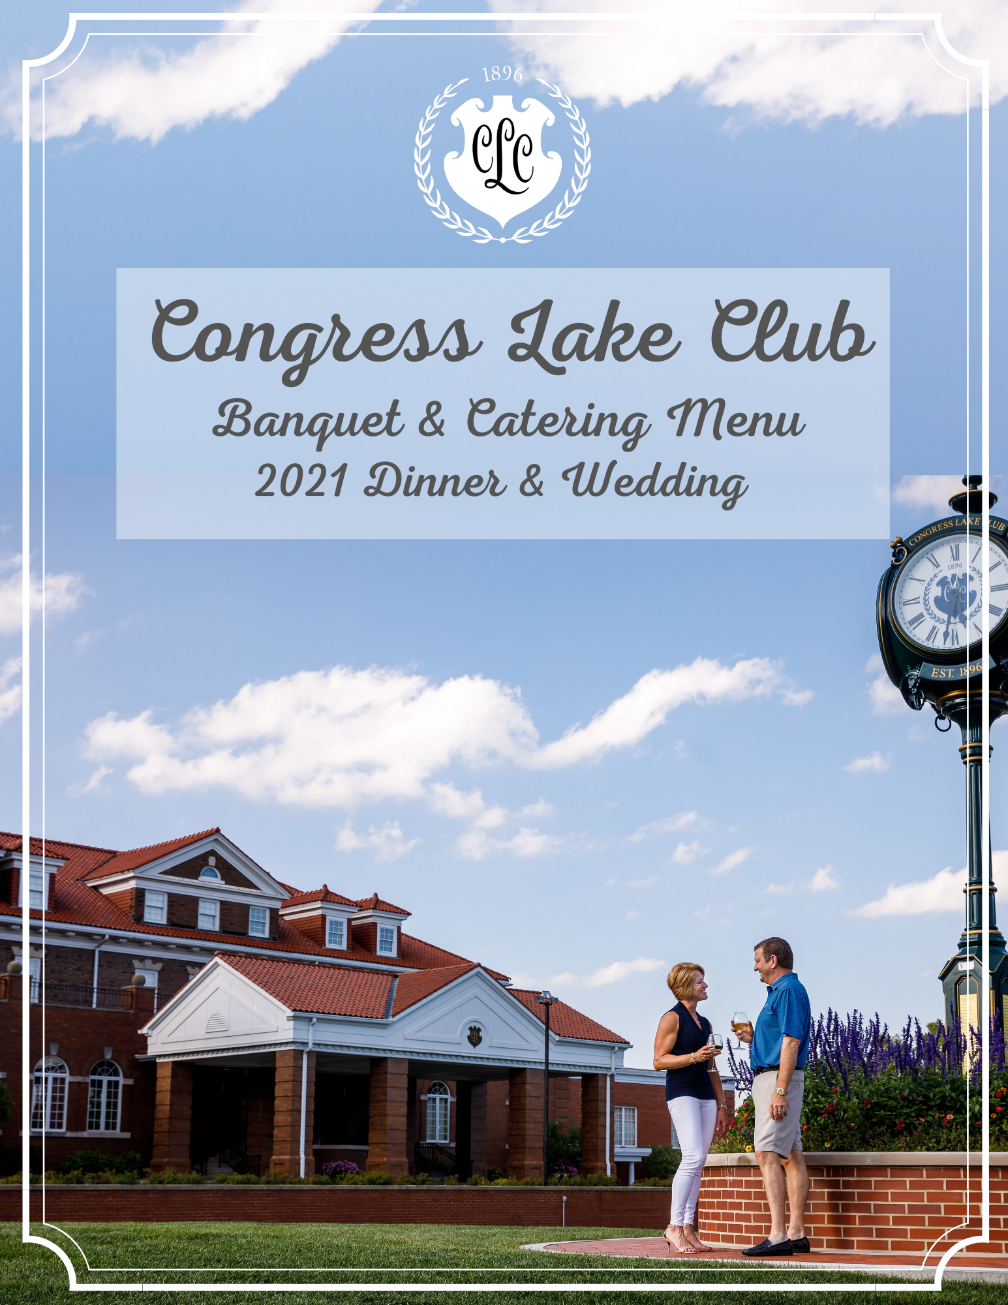

CONGRESS LAKE CLUB | 1 East Drive Hartville, Ohio 44632 | 330-877-9318
CLUB POLICIES & INFORMATION

Add information here….

CLUB POLICIES & INFORMATION

Continued….

HORS D’ OEUVRES

STATIONARY HORS D’ OEUVRES
(Based on a minimum of 20 guests & Priced per person)

EUROPEAN BISTRO, ARTISAN CHEESE, & FRUIT COMPOSITION - $13
A fine selection of imported and domestic cheeses, Parma ham, salami, assorted cured meats, imported olives, grilled balsamic vegetables, crostini, bruschetta, and market fresh fruit

MARKET VEGETABLE CRUDITE - $7
Market assorted raw vegetables and savory dip

SPINACH & ARTICHOKE- $5
Served with pita points

HUMMUS WITH PITA & CRACKERS- $5
ASPARAGUS WITH PROSCIUTTO- $5
PIMENTO WITH LAVASH- $5

PASSED or DISPLAYED HORS D’ OEURVES
(priced per dozen)
Shrimp & Grits- $32  Shrimp Cocktail- $32  Beef Roulade with Bleu Cheese-$34  Fried Green Tomatoes- $17  Spinach Stuffed Mushrooms- $19  Bacon Wrapped Scallops  Tuna on Wasabi Cracker- $36  Seared Duck on Crostini-$27  Spring Rolls | Smoked Salmon with Cheese Spread- $22  Beef Tenderloin with Toast Points Lamb-$36  Lamb Lollipops Mint Demi  Bruschetta-$19  She Crab Shooters  Crab Cakes with Gribiche  Meatballs  Spanakopita
PARTY PLATTERS

Shrimp Cocktail
$24 Dozen
Jumbo Chilled Shrimp, Cocktail Sauce, Lemons

Chicken Wings
Small $50 Approx. 36
Large $70 Approx. 60
Breaded Tossed With Choice Of Dressing
Served With Celery, Ranch, Blue Cheese Dressing

Chicken Tender Platter
Small $60 Approx. 24
Large $80 Approx. 40
Breaded Tossed With Choice Of Dressing
Served With Celery, Ranch, Blue Cheese Dressing

Deli Platter
$60 Serves 8-10 people
Roasted Turkey, Blackforest Ham, Pastrami
Swiss, Cheddar, American Cheese, Lettuce, Tomato, Onion

Cheese Platter
$70 Serves 8-10 people
Assorted Domestic and Imported Cheese, Grapes, Strawberries, Crackers
DINNER BUFFETS

Choose Two Entrees, Three Sides, and One Salad
Additional Entrée $10 per person
ROSS BUFFET
$44 PER PERSON
Sauteed Black Grouper
Crab Stuffed Flounder
Crab Cakes
Filet Oscar

CONGRESS BUFFET
$33 PER PERSON
Fried Flounder
Meat Lasagna
Shrimp & Grits
Blackened Mahi
Beef Bourguignon
Herb Roasted Salmon
Spaghetti & Meatballs

LAKE BUFFET
$27 PER PERSON
Chicken Parmesan
Chicken Marsala
Chicken Oscar
Chicken Cordon Bleu
Chicken Primavera
Roasted Pork Loin
Vegetarian Lasagna
Pork & Beans

MCKINLEY BUFFET
$37 PER PERSON
Shrimp Scampi
Shrimp Basilico
Shrimp Florentine
Beef Short Ribs
Ribeye Display
Strip Display

SIDES
House Soup
Wild Rice
Roasted Garlic Potatoes
Whipped Potatoes
Scalloped Potatoes
Red Skin Potatoes
Mushroom Risotto
Haricot Verts
Asparagus
SALADS
Caesar
House
Waldorf
Spinach
Beet

Kale
Quinoa
Arugula
Panzanella

Broccolini
Broccoli
Rice Pilaf
Vegetable Medley
Broccoli Casserole
Green Bean Almondine
French Green Beans
She Crab (add $2)

Pasta Station  ($14 per person)  Pasta: Penne, Farfalle & Cavatelli  Proteins: Housemade Meatballs, Grilled Chicken, Shrimp, Italian Sausage & Peppers  Sauces: Pesto, Alfredo, & Marinara  FISH TACOS  (market price)  Seasonal fish…tortillas, toppings, etc… | Carving Station  Priced per Person  Roast Turkey Breast - $18  Garlic Rosemary Crusted Pork Loin - $16  Salmon- $28  Prime Rib - $38  Roast Beef Tenderloin - $42
CHEF ATTENDED STATIONS
PLATED DINNER ENTREES

LAKE PLATES

Chicken Oscar
Whipped Potatoes, Asparagus,
Backfin Crab, Hollandaise

Chicken Saltimbocca
Prosciutto, Sage, Garlic Whipped Potatoes, Green Bean

Roasted Pork Loin
Whipped Potatoes, Broccoli, Mushroom Jus

Chicken Cordon Bleu
Smoked Gouda, Black Forest Ham,
Roasted Garlic Potatoes, Haricot Vert, Tomato Bechame

CONGRESS PLATES

Blackened Mahi Mahi
Wild Rice, Broccolini, Mango Salsa,
Beurre Blanc

Herb Roasted Salmon
Rice Pilaf, Broccoli, Tomato Confit,
Beurre Blanc

Shrimp & Grits
East Coast Shrimp, Stone Ground Grits,
Slab Bacon, Cream

Prime Rib
8oz Prime Rib, Whipped Potatoes, Broccolini, Mushroom Jus

MCKINLEY PLATES

Shrimp Scampi
East Coast Shrimp, Orzo,
Tomatoes, White Wine Butter

Crab Cakes
Rice Pilaf, Broccolini, Tomato Confit,
Beurre Blanc

Ribeye
12oz Ribeye, Whipped Potatoes,
Broccoli, Mushroom Jus

New York Strip
12oz Strip, Roasted Garlic Potatoes,
Broccoli, Mushroom Jus

ROSS PLATES

Surf & Turf
5oz Filet, Crab Cake, Whipped Potatoes,
Broccolini, Hollandaise

Crab Stuffed Flounder
Back Fin Crab, Fresh Flounder,
Rice Pilaf, Broccoli, Tomato Confit,
Beurre Blanc

Sauteed Black Grouper
Rice Pilaf, Broccoli, Tomato Confit,
Beurre Blanc

Filet Oscar
8oz Filet, Whipped Potatoes, Asparagus,
Backfin Crab, Hollandaise

SALAD ENHANCEMENTS

(Priced per person)

House Mixed green salad - $4
A blend of artisan mixed greens, cherry tomatoes, cucumber, pickled red onions,
red currants and pumpkin seeds

Caesar Salad - $4
Crispy romaine, creamy parmesan dressing, house croutons and parmesan crisp

Panzanella - $4.50
Description here….

beet salad - $4.50
Description here….

Wedge Salad - $4.25
Iceberg lettuce, bacon, tomatoes, and red onions

Spinach salad - $4
Description Here….

ALA CARTE MENU DINING
Dining groups of more than 14 but less than 30 may select a limited number of menu selections from the Club’s current Ala Carte Dining Menu. No more than 3 selections are permitted.

For plated meals, a single entrée menu is recommended for all guests when possible.
For plated meals over 100 guests, multiple entrée menus are limited to two (2) entrees.
Should more than two (2) entrée selections be necessary, a single price of the highest item will apply. The host is responsible to provide the Congress Lake Club the specific count and table location for entrée selections

DESSERTS

(Priced per person)

CHEESECAKE - $6

KEY LIME PIE - $6

BOURBON PECAN PIE - $7

MINI SHOOTERS - $7

A $2.50 per person cake cutting fee will be applied to every cake that is brought in from an outside vendor.

BEVERAGE SERVICE

(priced per person)

BEVERAGE STATIONS- $4
Hot Coffee (Regular and Decaf), Hot & Iced Tea, Bottled Water and Assorted Canned Sodas

SERVED COFFEE-$2.50
Regular or Decaf. Guest may select hot tea.

BAR PACKAGES

(Pricing applicable to all guests 21 & over)
(Congress Lake does not permit cash bar sales)

OPTION 1 HOSTED BEER & WINE BAR SERVICE

$12 per person per guarantee for the first hour

$4.50 for each additional per hour per guarantee

Domestic bottled beer (Budweiser, Miller &/or Coors Products),

House Wine (Cabernet & Chardonnay), Soft Drinks

OPTION 2 HOSTED BAR BASIC BAR SERVICE

$14 per person per guarantee for the first hour

$6.50 for each additional per hour per guarantee

House Liquor (Bourbon, Scotch, Vodka, Gin, Rum, Canadian Whiskey, Tequila,

House Cordials & Mixers), Domestic Bottled Beer (Budweiser, Miller &/or Coors Products),

House Wine (Cabernet & Chardonnay), Soft Drinks

OPTION 3 HOSTED BAR STANDARD SERVICE

$18 per person per guarantee for the first hour

$6.50 for each additional per hour per guarantee

Brand Name Liquor (Jim Beam, Dewar’s Scotch, Absolut Vodka, Tanqueray Gin,

Bacardi Rum, Canadian Club Whiskey, Jose Cuervo Tequila, House Cordials & Mixers),

Domestic Bottled Beer (Budweiser, Miller &/or Coors Products),

House Wine (Cabernet & Chardonnay), Soft Drinks

OPTION 4 HOSTED BAR PREMIUM SERVICE

$22 per person per guarantee for the first hour

$8.50 for each additional per hour per guarantee

Premium Brand Liquor (Jack Daniels, Johnnie Walker Red Scotch, Tito’s Vodka,

Beefeater Gin, Bacardi Rum, Crown Royal Whiskey, Jose Cuervo Tequila,

Call Cordials & Mixers), Domestic Bottled Beer (Budweiser, Miller &/or Coors Products), Craft & Imported Beers, Premium Wine (Cabernet & Chardonnay), Soft Drinks

WINE

Congress Lake Club offers an extensive Wine List for dinner service. Prices vary based upon the bottle. Wine Society discounts do not apply to private/catered functions. Ask our Banquet Director for details. There will be $15.00 per bottle corkage fee for all wine provided by host.

