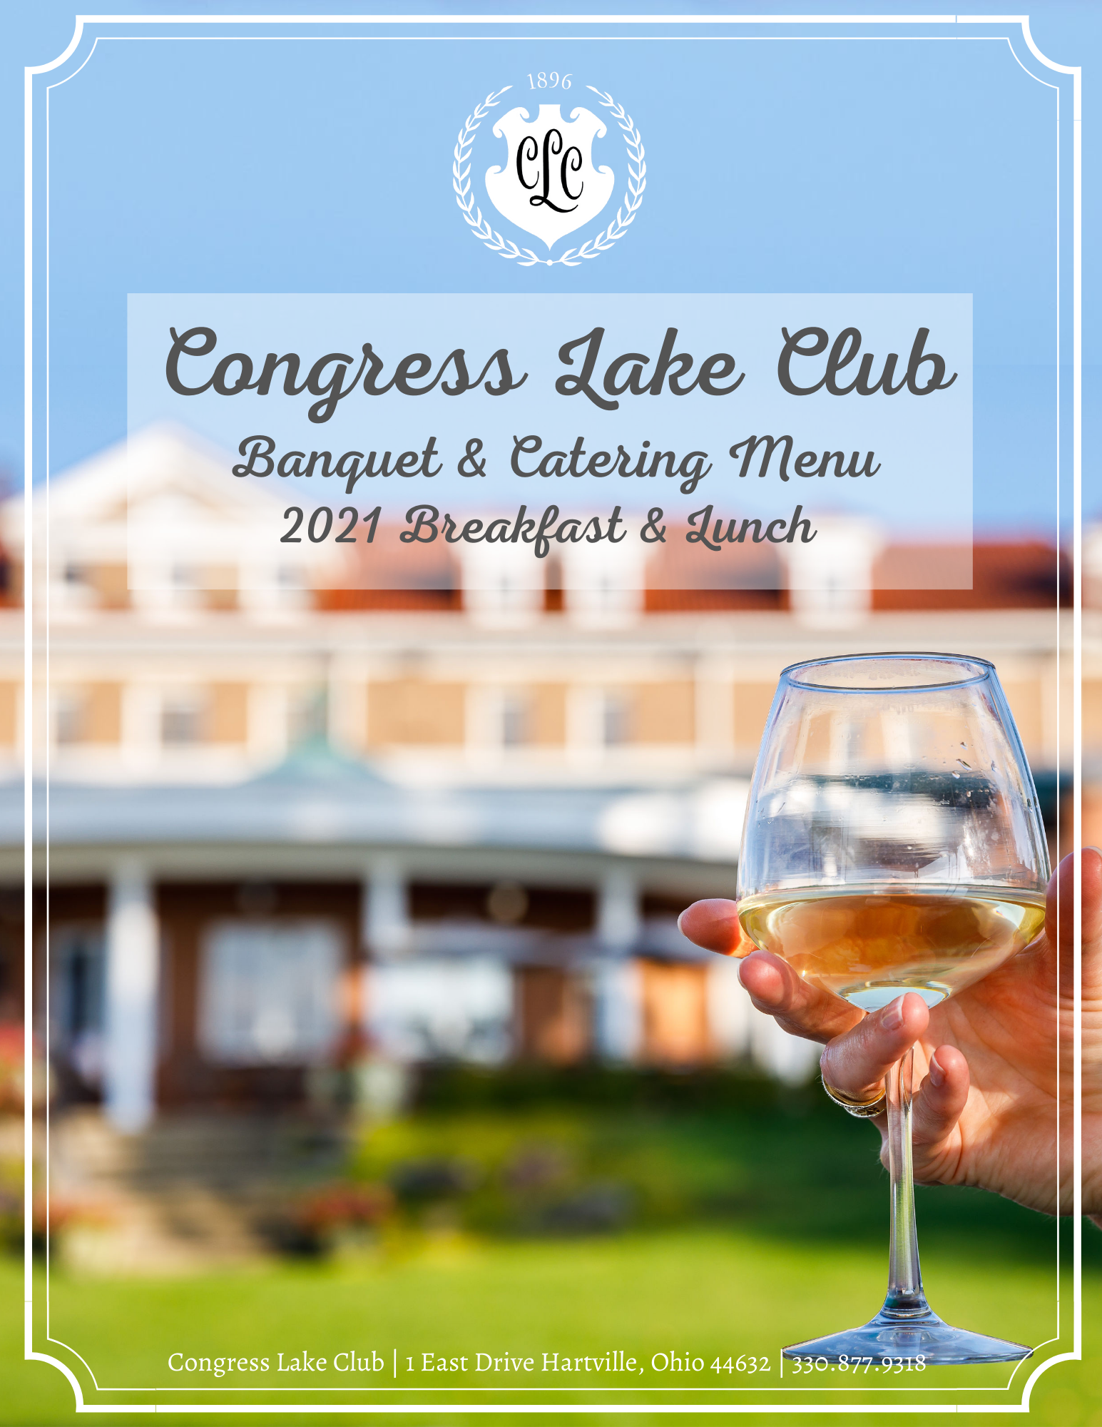

CONGRESS LAKE CLUB | 1 East Drive Hartville, Ohio 44632 | 330-877-9318
CLUB POLICIES & INFORMATION

Add information here….

CLUB POLICIES & INFORMATION

Continued….

HORS D’ OEUVRES

STATIONARY HORS D’ OEUVRES
(Based on a minimum of 20 guests & Priced per person)

EUROPEAN BISTRO, ARTISAN CHEESE, & FRUIT COMPOSITION - $13
A fine selection of imported and domestic cheeses, Parma ham, salami, assorted cured meats, imported olives, grilled balsamic vegetables, crostini, bruschetta, and market fresh fruit

MARKET VEGETABLE CRUDITE - $7
Market assorted raw vegetables and savory dip

SPINACH & ARTICHOKE- $5
Served with pita points

HUMMUS WITH PITA & CRACKERS- $5
ASPARAGUS WITH PROSCIUTTO- $5
PIMENTO WITH LAVASH- $5

PASSED or DISPLAYED HORS D’ OEURVES
(priced per dozen)
Shrimp & Grits- $32  Shrimp Cocktail- $32  Beef Roulade with Bleu Cheese-$34  Fried Green Tomatoes- $17  Spinach Stuffed Mushrooms- $19  Bacon Wrapped Scallops  Tuna on Wasabi Cracker- $36  Seared Duck on Crostini-$27  Spring Rolls | Smoked Salmon with Cheese Spread- $22  Beef Tenderloin with Toast Points Lamb-$36  Lamb Lollipops Mint Demi  Bruschetta-$19  She Crab Shooters  Crab Cakes with Gribiche  Meatballs  Spanakopita
PARTY PLATTERS

Shrimp Cocktail
$24 Dozen
Jumbo Chilled Shrimp, Cocktail Sauce, Lemons

Chicken Wings
Small $50 Approx. 36
Large $70 Approx. 60
Breaded Tossed With Choice Of Dressing
Served With Celery, Ranch, Blue Cheese Dressing

Chicken Tender Platter
Small $60 Approx. 24
Large $80 Approx. 40
Breaded Tossed With Choice Of Dressing
Served With Celery, Ranch, Blue Cheese Dressing

Deli Platter
$60 Serves 8-10 people
Roasted Turkey, Blackforest Ham, Pastrami
Swiss, Cheddar, American Cheese, Lettuce, Tomato, Onion

Cheese Platter
$70 Serves 8-10 people
Assorted Domestic and Imported Cheese, Grapes, Strawberries, Crackers
LUNCH BUFFETS

Choose Two Entrees, Three Sides, and One Salad
Additional Entrée $10 per person
LAKE PICNIC
$18 PER PERSON
Tuna Salad
Chicken Salad
Carved Roast Beef
Honey Baked Ham
Slow Roasted Turkey
Pesto Grilled Chicken
(sandwich bread, cheeses, and dressings included)

CONGRESS PICNIC
$20 PER PERSON
Pulled Pork
Cheeseburgers
All Beef Hot Dogs
Barbecue Chicken
Southern Fried Chicken
All Beef Mini Sliders
Pulled Pork Sliders

MCKINLEY PICNIC
$22 PER PERSON
Italian Sausage
Shrimp Basilico
Grilled Salmon
Fried Shrimp
Bratwaurst

SIDES
House Chips
Bagged Chips
Cole Slaw
Potato Salad
Fruit Salad
House Salad

Caesar Salad
Caprese Salad
Waldorf Salad
Spinach Salad
Panzanella
Pasta Salad

PLATED LUNCH ENTREES

Based on 10 guest minimum & priced per person

Cobb Salad $16
Mixed Greens, Grilled Chicken, Eggs, Bacon, Avocado, Blue Cheese, Tomatoes

Quiche Loraine $17
Tomatoes, Spinach, Gruyere Cheese, Hollandaise, Fresh Fruit

Chicken and Spinach Crepes $18
DISCRIPTION HERE

Wild Berry Chicken Salad $18
Mixed Greens, Grilled Chicken, Blackberries, Strawberries, Grapes, Toasted Almonds, Goat Cheese Crumbles, Red Onion, Poppy-Seed Dressing

Chicken Francaise $22
Chicken Scaloppini, Whipped Potatoes, Fresh Vegetables, lemon Butter Sauce

Southwest Chicken $22
Stewed Chicken, Polenta, Peppers, Onions, Tomatoes, Olives, Feta

Pork Loin $24
White Marble Pork, Whipped Potatoes, Fresh Vegetables, Wild Mushroom Jus

Beef Bourguignon $26
Tender Beef Tips, Whipped Potatoes, Carrots, Peas

Sirloin Steak $28
Prime 6oz Sirloin, Whipped Potatoes, Fresh Vegetables, Beurre Blanc

Blackened Mahi Mahi $32
Fresh Cut Mahi Mahi, Saffron Pilaf, Fresh Vegetables, Wild Mushrooms, Jus

Herb Roasted Salmon $32
Fresh Cut Salmon, Saffron Pilaf, Fresh Vegetables, Beurre Blanc

SALAD ENHANCEMENTS

(Priced per person)

House Mixed green salad - $4
A blend of artisan mixed greens, cherry tomatoes, cucumber, pickled red onions,
red currants and pumpkin seeds

Caesar Salad - $4
Crispy romaine, creamy parmesan dressing, house croutons and parmesan crisp

Panzanella - $4.50
Description here….

beet salad - $4.50
Description here….

Wedge Salad - $4.25
Iceberg lettuce, bacon, tomatoes, and red onions

Spinach salad - $4
Description Here….

ALA CARTE MENU DINING
Dining groups of more than 14 but less than 30 may select a limited number of menu selections from the Club’s current Ala Carte Dining Menu. No more than 3 selections are permitted.

For plated meals, a single entrée menu is recommended for all guests when possible.
For plated meals over 100 guests, multiple entrée menus are limited to two (2) entrees.
Should more than two (2) entrée selections be necessary, a single price of the highest item will apply. The host is responsible to provide the Congress Lake Club the specific count and table location for entrée selections

DESSERTS

DESSERT ADD-ONS
SWEET TOOTH

$3 Per Person, Choose one:
Brownies
Homemade Cookies
Southern Cobbler
SWEET ENDINGS
$5 Per person. Choose one:
Cheesecake
Key Lime Pie
Bourbon Pecan Pie
Derby Pie
Strawberry Shortcake
Mini Shooters

A $2.50 per person cake cutting fee will be applied to every cake that is brought in from an outside vendor.

BREAKFAST

Based on 10 guests minimum & priced per person

PLATED BREAKFAST

Beverage Only PRICE

Dock Breakfast $15
Danish, Muffins, Bagels, Assorted Juices, Coffee

Lake Breakfast $16
Fried Egg, Bacon and Cheese Sandwich, Fruit, Assorted Juices, Coffee

Congress Breakfast $19
Scrambled Eggs, Bacon, Biscuits and Gravy, Hash Browns, Assorted Juices, Coffee

BREAKFAST ENHANCEMENTS
Yogurt and Granola $4
Assorted Cereals $3
Omelet Station $6

BREAKFAST BUFFET

Congress Breakfast $27
Fruit Display, Assorted Pastries, Seasonal Salad, Grits, Bacon, Sausage, Hash Browns, Biscuits and Gravy, Scrambled Eggs

Golf & Go Boxed Breakfast
Choice of House Sausage Biscuit, Bacon Egg and Cheese Biscuit, or Fried Chicken Biscuit with Pimento Cheese, Whole Fruit, and Bottled Juice in To-Go Boxes

CONTINENTAL BREAKFAST
Beverage Only PRICE

Coffee & Pastry PRICE

Coffee & Breakfast PRICE

BEVERAGE SERVICE

(priced per person)

BEVERAGE STATIONS- $4
Hot Coffee (Regular and Decaf), Hot & Iced Tea, Bottled Water and Assorted Canned Sodas

SERVED COFFEE-$2.50
Regular or Decaf. Guest may select hot tea.

BAR PACKAGES

(Pricing applicable to all guests 21 & over)
(Congress Lake does not permit cash bar sales)

OPTION 1 HOSTED BEER & WINE BAR SERVICE

$12 per person per guarantee for the first hour

$4.50 for each additional per hour per guarantee

Domestic bottled beer (Budweiser, Miller &/or Coors Products),

House Wine (Cabernet & Chardonnay), Soft Drinks

OPTION 2 HOSTED BAR BASIC BAR SERVICE

$14 per person per guarantee for the first hour

$6.50 for each additional per hour per guarantee

House Liquor (Bourbon, Scotch, Vodka, Gin, Rum, Canadian Whiskey, Tequila,

House Cordials & Mixers), Domestic Bottled Beer (Budweiser, Miller &/or Coors Products),

House Wine (Cabernet & Chardonnay), Soft Drinks

OPTION 3 HOSTED BAR STANDARD SERVICE

$18 per person per guarantee for the first hour

$6.50 for each additional per hour per guarantee

Brand Name Liquor (Jim Beam, Dewar’s Scotch, Absolut Vodka, Tanqueray Gin,

Bacardi Rum, Canadian Club Whiskey, Jose Cuervo Tequila, House Cordials & Mixers),

Domestic Bottled Beer (Budweiser, Miller &/or Coors Products),

House Wine (Cabernet & Chardonnay), Soft Drinks

OPTION 4 HOSTED BAR PREMIUM SERVICE

$22 per person per guarantee for the first hour

$8.50 for each additional per hour per guarantee

Premium Brand Liquor (Jack Daniels, Johnnie Walker Red Scotch, Tito’s Vodka,

Beefeater Gin, Bacardi Rum, Crown Royal Whiskey, Jose Cuervo Tequila,

Call Cordials & Mixers), Domestic Bottled Beer (Budweiser, Miller &/or Coors Products), Craft & Imported Beers, Premium Wine (Cabernet & Chardonnay), Soft Drinks

WINE

Congress Lake Club offers an extensive Wine List for dinner service. Prices vary based upon the bottle. Wine Society discounts do not apply to private/catered functions. Ask our Banquet Director for details. There will be $15.00 per bottle corkage fee for all wine provided by host.

