Super Bowl 2021 Take-Out Menu
Each tray serves 6-8 people.
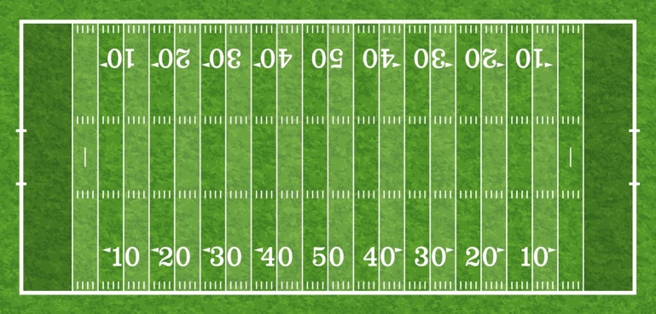
Orders must be placed by Thursday, February 4th at 3:00pm.
All hot food has been fully cooked. Please reheat to an internal temperature of 145°

3-Foot Italian Sub $69
Pepperoni, Salami, Capicola,
Provolone, Tomato, Shredded Lettuce,
Red Onions, Italian Vinaigrette
FECC Kettle Chips, Pickle Chips
QTY:_____

Tex-Mex Salad Bar $68
Let us provide you with your own Salad Bar
Bowls of Romaine and Iceberg Lettuce,
Griddled Adobo Chicken,
Roasted Lemon Pepper Shrimp,
Cilantro Tomatoes, Banana Peppers, Guacamole, Griddled Corn, Black Beans,
Monterey Jack & Cheddar Cheese
Crisp Fajita Strips,
Chipotle Dressing, Red Wine Vinaigrette
QTY:_____

Dipping Station $58
Baba Ghanoush, Classic Hummus,
Chipotle Salsa
Cumin-Dusted Pita, Tortilla Chips,
Herb Crostini, Pickled Vegetables
QTY:_____

Shrimp Cocktail $70
Horseradish, Cocktail Sauce, Lemon
QTY:_____
Package of (4) Long Sleeve Fiddler’s Superbowl T-Shirts $20
*While supplies last

QTY:________ Sizes:_________________
*Don’t forget to tag us on Instagram @fiddlerselbowcc wearing your t-shirt for a chance to win fun prizes!

Baked Tortellini Alfredo $42
Add Grilled Chicken $18
QTY:_____

Mini Franks $42
Sweet Mustard
QTY:_____

Stuffed Mushrooms $46
Chicken & Spinach Stuffing
QTY:_____

Pulled Heritage Pork Sliders $65
Hawaiian Slider Buns, Smoky BBQ Sauce,
Pickled Vegetable Slaw
QTY:_____

Crab Cakes Sliders $64
Cajun Remoulade
QTY:_____

4-Dozen Baked Jumbo Wings $72
Buffalo Sauce, Blue Cheese Dip, Celery Sticks
QTY:_____

Turkey Chili (64 oz) $54
Tricolor Tortilla Chips,
Cheddar Cheese, Scallions
QTY:_____

Name:________________________________________________ Member Number: _______________

Phone Number:________________________ Email:___________________________________________

Pickup Time (12:00pm-3:00pm on Super Bowl Sunday):_________________________

Please send completed form to Brenda Cabrera at bcabrera@fiddlerselbowcc.com
*If you do not receive a confirmation email within 24 hours of your order, please call (908)669-4309
100% will be applied towards monthly food minimum. NJ sales tax applies.

