Pinot Camp Wine Dinner
Friday, April 8, 2016

Reception
Roederer Estate

First Course
Nova Scotia Halibut
Spring Peas, White Asparagus Salad, Poached Butter Radishes

2014 Williamette Valley Pinot Gris

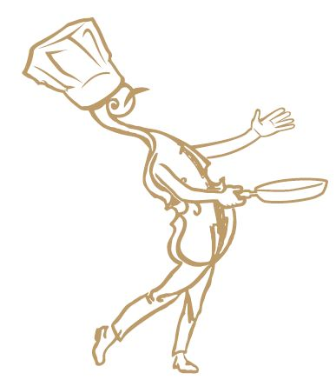
Second Course
Toro
Saffron Risotto, Leeks, Morel Mushroom Gremolata

2013 Siduri Williamette Valley Pinot Noir

Third Course
Duo of Maple Leaf Duck Breast
& Rillettes
Navy Beans, Haricot Verts, Tempura Ramps

2012 Domaine Anderson Pinot Noir

Fourth Course
Tenderloin of Beef & Buffalo
Braised Parsnip, Charred Carrot Mousseline, House Smoked Bacon Jus

Hartford Court Seascape

Dessert
Orange Glazed Spiced Poached Anjou
Pear, Mascarpone Gelato
Hosted by Michele Zuckerman
Executive Chef Michael Weisshaupt

Domaine Schlumberger Pinot Blanc 2013

