Kelly Greens Golf & Country Club
Banquets and Weddings
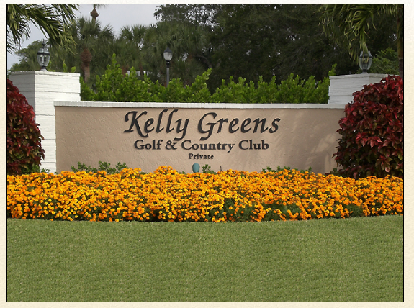
12300 Kelly Greens Boulevard S.W.
Fort Myers, FL 33908
www.kellygreens.com
Club House Phone Number- 239-466-9570
Club House Fax Number- 239-466-1016

Food and Beverage Manager . Jo-Ann Koehn
Executive Chef . Drew Tait

Updated 12/24/20

Breakfast Buffets

Kelly Greens Continental
Tropical fruit display
Assorted breakfast breads and pastries
Fresh squeezed Florida orange juice
Freshly brewed coffee, decaf and hot tea
$15 per person

Kelly Greens Deluxe Continental
Tropical fruit display with exotic fruits and berries
Toasted bagels with assorted cream cheese
Assorted breakfast breads
Assorted yogurts with granola
Seasonal whole fruit
Fresh squeezed Florida orange juice
Freshly brewed coffee, decaf and hot tea
$20 per person

The 9th Green
Tropical fruit display
Assorted yogurts with granola
Breakfast breads and pastries
Roasted red potatoes with onions and bell peppers
Scrambled eggs
Applewood Smoked Bacon and Sausage
Fresh Florida orange juice
Freshly brewed coffee, decaf and hot tea
$23 per person

The 18th Green
Tropical fruit display
Assorted yogurts with granola
Assorted bagels with cream cheese
Roasted red potatoes with onions and bell peppers
Scrambled eggs
Applewood Smoked Bacon and Sausage
French toast with whipped butter and maple syrup
Eggs benedict with hollandaise sauce
Fresh Florida orange juice
Freshly brewed coffee, decaf and hot tea
$29 per person

Boxed Lunches
All picnic box lunches are served with potato chips, condiments, whole fruit and a cookie

Roast Beef
Roast top round, caramelized onions, Swiss cheese, horseradish cream and lettuce on a French roll
$18 per person

Oven Roasted Turkey Breast
Swiss cheese, crisp romaine, red onion and Honey Mustard Dressing on a Hoagie Roll
$16 per person

Cured Ham
Provolone cheese, sliced tomato, lettuce and Spicy Mustard on a brioche bun
$16 per person

Classic Grilled Chicken Caesar Wrap
Crisp romaine lettuce, parmesan cheese, Caesar dressing and grilled chicken in a flour tortilla
$17 per person

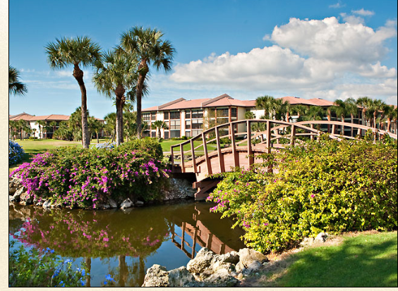

Lunch Buffets
Deli Buffet
Soup du Jour
Pasta salad
Mixed field greens salad with tomato, cucumber, carrot and red onion
Sliced turkey breast, roast beef and ham
Sliced cheeses, lettuce, tomato and assorted breads
Potato chips
Freshly baked cookies
Freshly Brewed Coffee, Decaf and Iced Tea
$23 per person

All American
Home style potato salad
Coleslaw
Tossed mixed green salad
Grilled all beef hot dogs
Hamburgers
Herb grilled chicken breast
Baked creamy macaroni and cheese
Maple bacon baked beans
Corn on the cob
Lettuce, tomato, onion, cheese, pickle, relish, ketchup,
Mustard and mayo
Strawberry shortcake and apple crumb cheesecake bar
$32 per person

Executive Lunch
Cabbage and fennel slaw
Bow tie pasta salad with artichoke hearts and sun-dried tomato pesto
Build your salad station:
Two types of lettuce
Sliced cucumber, tomatoes, onions, roasted red peppers, olives, chickpeas and mushrooms
Balsamic vinaigrette & ranch dressings
Herb grilled chicken breast
Roasted, chilled and sliced peppercorn crusted beef tenderloin
Brie and gouda cheese’s with grapes, strawberries and assorted crackers
Petite fours and pastries
$47 per person

Reception Table
Serves up to 50 people

Tropical Fruit Display
Sliced pineapple, honeydew, cantaloupe and chef selected seasonal fruits garnished with berries and grapes $250

Crudité Platter
Crisp zucchini, yellow squash, cherry tomatoes, baby pickles, sweet bell peppers and carrots served with creamy green onion ranch dip $200

Great Cheese Board
A selection of import and domestic cheeses to include double crème brie, boursin, Saint Andre, Maytag blue and Vermont goat cheese garnished with dried fruits and candied walnuts
Served with a selection of assorted gourmet crackers $275

Build Your Own Slider Bar
Smoked and braised beef shoulder, BBQ pulled pork and fresh jumbo lump crab cakes served with soft brioche slider rolls. Accompanied with caramelized onions, roasted red pepper coulis, sweet mango remoulade, lettuce, tomato and red onion $450

Chilled Raw Bar Display
Poached jumbo shrimp, oysters on the half shell and snow crab claws accompanied with raw horseradish, cocktail sauce, tabasco and lemon wedges
$825

Jumbo Shrimp Cocktail
Poached jumbo shrimp served with cocktail Sauce and lemon wedges
(3 shrimp per person)
$375

Cold Canape Platters
Includes 50 pieces of each item

Shrimp ceviche shooter $300
Seared tuna with spicy aioli $250
Chilled bloody Mary oyster shooter $300
Crab tostada, avocado, salsa, crisp tortilla $250
Asparagus wrapped prosciutto ham $250
Beef carpaccio with horseradish cream on crostini $250
Jumbo shrimp cocktail $300
Savory mushroom, spinach, goat cheese tarte with pine nuts $200
Tomato Bruschetta $150

Hot Canape Platters
Includes 50 pieces of each item

Grilled marinated baby lamb chops with demi-glace $350
Bacon wrapped scallops $300
Jerk chicken skewer with pineapple creole sauce $200
Beef tenderloin in flaky pastry $200
Coconut shrimp with zesty orange marmalade $300
Brie and raspberry wrapped in puff pastry $200
Maryland jumbo lump crab cake, mango remoulade $350
Beef satay with Thai teriyaki glaze $250
Peking duck spring roll with hoisin glaze and scallion $250
Beef empanada with a chipotle aioli $200
Vegetable spring roll with sweet chili sauce $200
Pork pot sticker with yuzu garlic soy sauce $175
Chicken satay with Thai peanut sauce $250
Swedish meatballs in a light beef gravy $150

Action Stations
Based on 60 minutes of continuous service
*Denotes $125 chef fee

Shrimp Scampi Station *
Jumbo shrimp tossed in lemon garlic butter. Served with linguine tossed in olive oil and garlic with assorted breads
$18 per person

Pasta Station *
(Select two pastas)
Penne, farfalle, cheese ravioli and rotini
(Select two sauces)
Marinara, pesto cream, three cheese alfrado, roasted red pepper sauce, olive oil and garlic
(Select two additions)
Julienne vegetables, Italian sausage, Mediterranean mix, grilled chicken, baby shrimp and bay scallops
All pastas come with parmesan cheese and garlic bread sticks
$12 per person
$3 per additional ingredients

Carving Stations
Based on 60 minutes of continuous service
*Denotes $125 chef fee

American Steamship Round *
Slow roasted with horseradish cream, tarragon mustard sauce and arugula salad served with hinged French rolls
(Serves 100 guests) $700
Whole Roasted Beef Tenderloin *
Served with wild mushrooms with au poivre sauce served with hinged French rolls
(Serves 25 guests) $280
Slow Roasted Prime Rib *
Served with au jus reduction and horseradish cream with hinged French rolls
(Serves 30 guests) $475
Tamarind Glazed Turkey *
Roasted double breast tamarind glazed turkey with orange cranberry jam and lemon mustard aioli served with hinged French rolls
(Serves 30 guests) $200
Honey Glazed Ham *
Served with spicy mustard and hinged French rolls
(Serves 30 guests) $150

Buffet Selections
Minimum of 50 people
*Denotes $125 chef fee
Each buffet includes fresh baked rolls, sweet butter, freshly brewed coffee and assorted teas

A Night in Tuscany

Caprese salad of vine-ripe tomatoes, fresh mozzarella, fresh basil, balsamic vinegar and extra virgin olive oil
Antipasto display of dried and cured meats, artichoke hearts, roasted peppers and marinated olives with parmesan and gorgonzola cheeses
Tossed Caesar salad with croutons, shaved parmesan cheese and creamy Caesar dressing

Penne pasta with Italian sausage, spicy plum tomato sauce and grated parmesan
Potato gnocchi with broccolini and roasted eggplant with basil pesto cream
Breast of chicken with lemon, capers and white wine
Grilled rosemary sliced flank steak, Marsala and mushroom ragout
Sautéed shrimp over linguini tossed in a scampi lemon butter
Parmesan and truffle infused potato gratin
Sautéed squash and zucchini

Flourless chocolate cake with marinated berries,
Tiramisu and Cannoli’s
$59 per person

Global Journey*

Tossed field greens with cherry tomatoes, cucumbers, shredded carrots and croutons served with creamy herbed ranch dressing and raspberry vinaigrette
Caesar salad with croutons and shaved parmesan cheese
Moroccan couscous salad with toasted almond, raisin and roasted red pepper

Hand carved slow roasted prime rib of beef with natural jus and horseradish cream
Pan seared chicken topped with artichoke hearts, spinach and pine nuts spooned with roasted red pepper cream
Lemon thyme seared grouper drizzled with grain mustard emulsion, braised fennel and wilted spinach
Fresh basil and garlic infused roasted vegetables
Toasted almond and golden raisin mixed basmati rice

Selection of mini petite fours, mini pastries and chocolate covered strawberries
$63 per person

Island Life*

Heart of palm salad with jumbo lump crabmeat, diced avocado, tomato and green onion with lemon vinaigrette
Jamaican sweet potato salad
Tropical rock shrimp salad with fresh spinach and citrus vinaigrette

Hand carved roasted chili and molasses rubbed beef striploin
Pan seared mahi-mahi with sweet peppers, charred corn and topped with green papaya slaw
Grilled Caribbean spiced chicken breast with coconut curry cream
Garlic and herb roasted red bliss potatoes
Mélange of seasonal fresh vegetables

Key lime pie, mango cheesecake with coconut whipped cream and fresh baked white chocolate macadamia nut cookies
$67 per person

Surf and Turf*

Marinated asparagus and roasted red pepper salad in extra virgin olive oil
Roasted fingerling potato salad, scallions, smoked, bacon, creamy whole grain mustard dressing
Haricots vert salad with roasted tomatoes, shaved red onions, fresh cracked black pepper and red wine vinaigrette

Hand carved roasted tenderloin with creamy horseradish sauce and au jus
Butter poached lobster tails, drawn butter
Sugarcane skewered shrimp
Three cheese tortellini with garlic parmesan cream, wilted spinach and roasted tomatoes
Whipped potatoes topped with fried onion
Fresh vegetable sauté of the season

Coconut cake, fresh fruit tarts and chocolate torte
$70 per person

Plated Selections
Each dinner includes soup or salad, dessert, fresh baked rolls, sweet butter, freshly brewed
Coffee and assorted teas

Soup & Salad Selections
Choose one soup or salad to begin your experience

Soups

Roasted Red Pepper
Chicken Noodle
Minestrone
Italian Wedding
NE Clam Chowder
Seafood Bisque

Salads
Mixed field green salad with candied walnuts, wedged tomato, sliced cucumber and shredded carrot with citrus dressing
Baby spinach with pickles red onions, fresh apples, candied walnuts, dried cherries, crumbled goat cheese with balsamic vinaigrette
Iceberg lettuce with vine ripe tomato, red onion, bleu cheese crisp bacon and herb ranch dressing

Entree Selections
Choose one entrée

Oven Roasted Local Grouper and Tenderloin
Oven roasted local grouper and grilled tenderloin with potato puree, heirloom tomato chutney, green beans and herb demi $63
Salmon
Served over roasted fingerling potatoes, braised leeks and sautéed mushrooms, spooned with lemon fennel cream $41
Petite Filet and Jumbo Crab Cake
Classic petite filet and jumbo lump crab cake with au gratin potatoes and baby vegetables served with a bordelaise sauce and Meyer lemon aioli $56
Grilled Filet Mignon
Roasted garlic mozzarella mashed potatoes, asparagus and carrots spooned with red wine reduction $53
Grilled New York Strip
Bleu cheese mash, roasted root vegetable medley and cabernet reduction $50
Roasted Salmon and Chicken
Boursin polenta and haricot verts, served with a grain mustard cream $46
Pan Seared Mahi Mahi
Oven roasted fingerling potatoes, topped with tomato, olives and capers $48
Boursin Crusted Pork Chop
Lemon and herb couscous, baby carrots, sautéed spinach and smoked tomato cream $43
Herb Crusted Filet
Heirloom tomato, artichoke and mushroom ragout, roasted garlic Yukon gold potatoes and demi $54
Alternatives
Eggplant Napoleon
Roasted eggplant, fresh mozzarella, tomato basil sauce $35
Ratatouille Stuffed Mushrooms
Classic ratatouille, herb stuffed mushrooms, grilled baguette and fresh basil $40
Dessert Enhancements
Based on 60 minutes of continuous service
*Denotes $125 chef fee

Bananas Foster Station*
Traditional banana rum foster sauce, fresh bananas, vanilla ice cream $12 per person

Sundae Bar
Local Love Boat strawberry, vanilla and chocolate ice cream
With whipped cream, chocolate syrup, caramel sauce, sliced strawberries, m&m's, crushed Oreos, sprinkles and candied walnuts $13 per person

French Pastries
Assorted display of petite fours, mini cakes, tarts and chocolate dipped strawberries $14 per person

Deluxe Coffee Bar
Freshly brewed coffee with hazelnut, French vanilla, peppermint and cherry syrup
Accompanied with whipped cream, cinnamon sticks shaved chocolate and sugar cane swizzle sticks $9 per person

Wedding Party Enhancements
While you and your bridal party prepare for your big moment enhance their time with some delights

Happiness
Fresh kettle chips, warm soft pretzels and fresh popped popcorn with individual bottles of root beer $19

Light and Fresh
Sliced apples, melons and citrus segments with dried fruits and banana chips
Mini parfaits with fresh berries, granola, yogurt and lavender infused honey with a selection of gourmet hot teas $21

Pampered
Assorted fresh baked cookies, brownies and individual bottles of chilled milk $15

Renew
Dried fruits, warm almonds, walnuts and cashews with fresh pomegranate and orange drink $15

Refreshed
Freshly brewed coffee, selection of gourmet teas assorted sodas, bottled still and sparkling water $8

Wedding Ceremony Package
$600
Package Includes
Private site for your wedding ceremony
50 White garden folding chairs
Refreshing iced tea and orchid-lemon infused water
Photo shoot at the covered bridge on the 9th green
Reserved back-up space within the clubhouse in case of inclement weather
Champagne toast

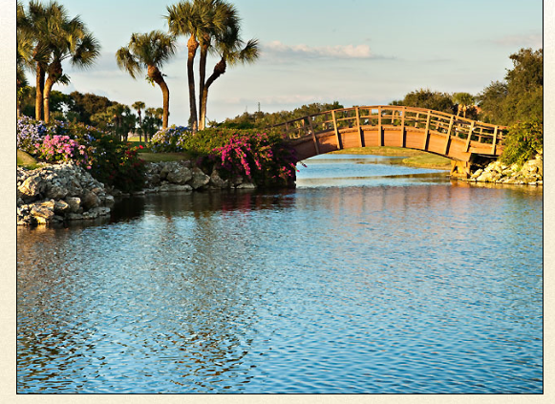

The Diamond Package
$85.00 per person
Minimum 50 people
Includes the following:

Package Includes
Private site for your wedding ceremony
50 White garden folding chairs
Refreshing iced tea and orchid-lemon infused water
Photo shoot at the covered bridge on the 9th green
Reserved back-up space within the clubhouse in case of inclement weather
Champagne toast
Cake cutting

Bridal Room with full length mirror
Allows the Bride for last minute touch ups in a relaxing atmosphere with cool beverages and a small sliced fruit plate

Each dinner includes fresh baked rolls, sweet butter, freshly brewed coffee and assorted teas

Choose One Salad
Mixed field green salad topped with candied walnuts, wedged tomato, sliced cucumber and shredded carrot with citrus dressing
Baby spinach with pickles red onions, fresh apples, candied walnuts, dried cherries, crumbled goat cheese with balsamic vinaigrette
Iceberg lettuce crowned with, vine ripe tomato, red onion, bleu cheese crisp bacon and herb ranch dressing

Choose Two Entrees
Pan seared salmon with smoked tomato-basil butter
Horseradish and herb crusted chicken breast with red wine butter
Grilled 8 oz. top sirloin with wild mushroom demi-glace
Grilled salmon with parmesan herb butter
Boneless breast of chicken with classic Marsala and mushroom sauce
Grilled mahi-mahi with pineapple salsa
Grilled 6oz beef tenderloin spooned with a white truffle demi-glace
Jerk seasoned pork tenderloin with mango glaze
Lemon thyme seared grouper drizzled with grain mustard emulsion
Pan seared chicken breast with lemon caper beurre blanc
Cinnamon and ginger scented pork chop with whole grain mustard sauce

Starch Selections
Select One

Garlic whipped potatoes
Roasted rosemary red bliss potatoes
Rice pilaf
Whipped sweet potatoes with maple-vanilla butter
Cauliflower and Yukon gold potato puree
Fontina polenta
Four cheese roasted garlic whipped potatoes
Saffron rice
Coconut rice with fresh thyme

Vegetable Selections
Select One

Squash medley
Broccoli
Green beans almandine
Cauliflower
Chef’s choice of seasonal vegetable
Roasted root vegetable medley
Butter and parsley baby carrots
Sautéed spinach

The Platinum Package
$110.00 per person
Minimum 50 people
Includes the following:

Package Includes
Private site for your wedding ceremony
50 White garden folding chairs
Refreshing iced tea and orchid-lemon infused water
Photo shoot at the covered bridge on the 9th green
Reserved back-up space within the clubhouse in case of inclement weather

Bridal Room with full length mirror
Allows the Bride for last minute touch ups in a relaxing atmosphere with cool beverages and a small sliced fruit plate

Each plated dinner includes fresh baked rolls, sweet butter, freshly brewed coffee and assorted teas

Choose One Salad
Caprese salad of vine-ripe tomatoes, fresh mozzarella, fresh basil, balsamic vinegar and extra virgin olive oil
Heart of palm salad with jumbo lump crabmeat, diced avocado, tomato and green onion with lemon vinaigrette
Mixed field green salad topped with candied walnuts, wedged tomato, sliced cucumber and shredded carrot with citrus dressing
Tropical rock shrimp salad with fresh spinach, Bermuda onion, sliced cucumber and citrus vinaigrette
Haricots vert salad with garlic roasted tomatoes, shaved red onions, grilled baguette, fresh cracked black pepper and red wine vinaigrette

Choose Two Entrees
Grilled 12oz New York strip steak spooned with a peppercorn cream demi-glace
Pan seared halibut drizzled with a roasted tomato cream
Pan roasted bone in chicken breast spooned with a wild mushroom sauce
6oz beef tenderloin drizzled with a red wine and shallot reduction
Herb breadcrumb encrusted wild salmon with lemon dill beurre blanc
Two poached cold water 5oz lobster tails with drawn butter
Duo of jumbo lump crab cakes spooned with a lemon aioli
Grilled 14oz bone in pork chop with cinnamon roasted apples and drizzled with calvados sauce
Herb encrusted rack of lamb with fennel pollen demi-glace
Pan seared 12oz Delmonico steak topped with roasted garlic and shallot compound butter

Starch Selections
Select One

Truffle parmesan au gratin potato
Fragrant Jasmin rice with fresh herbs
Twice baked potato
Whipped sweet potatoes
Herbed fingerling potatoes
Bleu cheese whipped potatoes
Lemon and herb couscous
Boursin polenta
Saffron rice pilaf
Fontina risotto cake

Vegetable Selections
Select One

Sautéed Haricot verts
Baby vegetables with fresh basil
Butter braised leeks
Grilled asparagus
Sautéed baby carrots
Squash and zucchini
Green beans almandine
Sautéed spinach

Dessert Enhancements
Based on 60 minutes of continuous service
*Denotes $125 chef fee

Bananas Foster Station *
Traditional banana rum foster sauce, fresh bananas, vanilla ice cream $12 per person

Sundae Bar
Local Love Boat strawberry, vanilla and chocolate ice cream
With whipped cream, chocolate syrup, caramel sauce, sliced strawberries, m&m's, crushed Oreos, sprinkles and candied walnuts $13 per person

French Pastries
Assorted display of petite fours, mini cakes, tarts and chocolate dipped strawberries $14 per person

Deluxe Coffee Bar
Freshly brewed coffee with hazelnut, French vanilla, peppermint and cherry syrup
Accompanied with whipped cream, cinnamon sticks shaved chocolate and sugar cane swizzle sticks $9 per person

