Annual Winemakers Dinner
Saturday, August 11, 2018

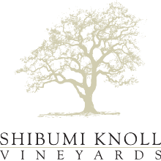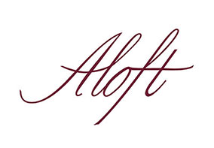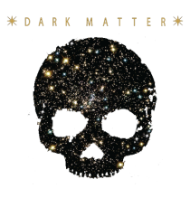

Tuna Sashimi, Avocado, Passionfruit Pearls
Charles Krug Sauvignon Blanc, 2017

Seared Atlantic Halibut
Leek, Fennel, Summer Peach
Shibumi Knoll Chardonnay, 2015

Chanterelle and Morel Mushroom Croustade
Grilled Black Mission Fig, Mascarpone
Shibumi Knoll Pinot Noir, 2014

Brandt Farm Beef Meatballs
Braised Red Cabbage, Aged Parmigiano, Red Wine Demi-Glace
Shibumi Knoll Cabernet Sauvignon, 2014

Rosemary Roasted Lamb Ribeye
Crispy Potato Tian, Roasted Baby Romanesco, Blackberry Demi-Glace
Aloft Cabernet Sauvignon, 2013

Dark Chocolate Studded Warm Bing Cherry Pie
Fig Glace, Berry Coulis
Dark Matter Zinfandel, 2009

