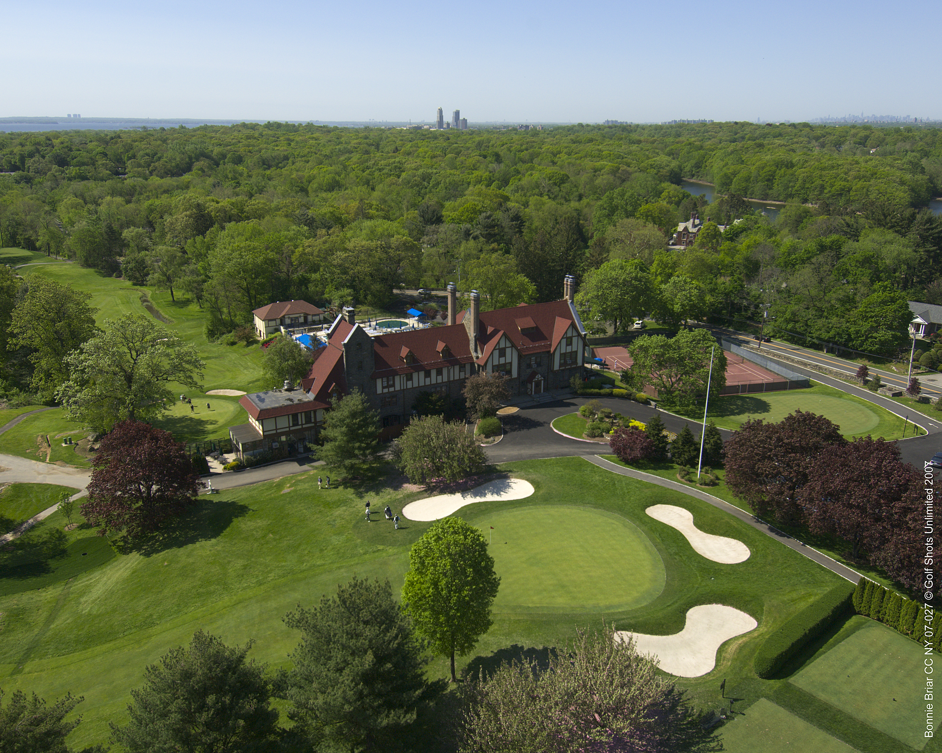

Bonnie Briar Country Club
2020 Golf Outings
Bonnie Briar Country Club Golf Outings
Breakfast Options

Simply Continental

Selection of Sliced Seasonal Fresh Fruit
Assortment of Miniature Breakfast Pastries and House Baked Muffins
Bagels with Cream Cheese, Butter and Preserves
Assortment of Cold Cereals
Bananas
Whole Milk and Skim Milk

Plain and Flavored Yogurts with Granola

Freshly Brewed Coffee, Decaffeinated Coffee and Select Teas

$15.00 per person

Option of
Omelet Station
Prepared to Order with Farm Fresh Eggs and Egg Whites
Fillings to Include Roasted Wild Mushrooms, Onions, Spinach,
Tomatoes, Broccoli, Grated Cheddar Cheese, and Ham

Add $7.00 per person

Home Style Buffet

Selection of Sliced Seasonal Fresh Fruit
Assortment of Miniature Breakfast Pastries and House Baked Muffins
Bagels with Cream Cheese, Butter and Preserves
Assortment of Cold Cereals
Bananas
Whole Milk and Skim Milk

Omelet Station
Prepared to Order with Farm Fresh Eggs and Egg Whites
Fillings to Include Roasted Wild Mushrooms, Onions, Spinach,
Tomatoes, Broccoli, Grated Cheddar Cheese and Ham

Hickory Smoked Bacon, Breakfast Sausage
Hash Browned Potatoes

Vanilla Brioche French Toast with Maple Syrup and Seasonal Fruit Compote

Freshly Brewed Coffee, Decaffeinated Coffee and Select Teas

$28 per person

The AW Tillinghast Executive Brunch

Selection of Sliced Seasonal Fresh Fruit

Assortment of Miniature Breakfast Pastries and House Baked Muffins
Bagels with Cream Cheese, Butter and Preserves

Omelet Station
Prepared to Order with Farm Fresh Eggs and Egg Whites
Fillings to Include Roasted Wild Mushrooms, Onions, Spinach,
Tomatoes, Broccoli, Grated Cheddar Cheese, Salsa and Ham

House Smoked Salmon
Served with Whipped cream Cheese, Minced Shallots, Capers and Chopped Egg
Cocktail Pumpernickel Bread

Hot Selections
Hickory Smoked Bacon and Breakfast Sausage
Roasted Yukon Gold Potatoes with Caramelized Onions
New England Buttermilk Pancakes with Real Maple Syrup

The Carvery
Our Signature Salmon en Croute with Shrimp Mousse and Tarragon Sauce
And
Roasted Beef Sirloin with Merlot Sauce

Desserts
Classical Tortes, Club Baked Pies, Miniature Pastries and Cookies

Freshly Brewed Coffee, Decaffeinated Coffee and Select Teas

$42 per person

Bonnie Briar Country Club Golf Outings
Lunch Options

Lunch on the Course at Holes 5 and 15 or On the Terrace

Assortment of Fresh Buns and Rolls
Lettuce, Tomato, Red Onion and Pickles
Ketchup, Mustard and Mayonnaise

Grilled Chicken with BBQ Sauce
BBCC Beef Hamburgers and Cheeseburgers
All Beef Hot Dogs

Warm Baked Beans, Chili and Sauerkraut

Macaroni & Potato Salad on Ice

Assorted Cookies and Brownies
Whole Fruit

$29 per person

Artisan Butcher Block Lunch

Chefs Soup of the Day

Fresh Mozzarella Cheese, Red Quinoa, Tomatoes, Artichokes and Arugula

Charred Sirloin and Portobello Mushroom Kale Caesar Salad

Tossed Organic Mixed Greens with Assorted Toppings and Two Salad Dressings

Spiced Shrimp Salad on Grilled New England Rolls
Open Faced Curry-Mango Chicken Salad on 7 Grain Bread
Fresh Roasted Turkey and Avocado BLT with Mayonnaise on Rye
Mediterranean Wraps with Goat Cheese, Grilled Vegetables and Hummus

Grilled Chicken Flatbread Pizzas with Capers, Lemon Zest, Basil and Parmesan Cheese

Seasonal Fresh Fruit Salad with Mint
Chocolate Biscotti
Selection of House Baked Cookies

Freshly Brewed Coffee, Decaffeinated Coffee, Select Teas and Iced Tea

$34 per person

Deli Style Lunch Buffet

Chefs Soup of the Day

Tossed Organic Mixed Greens with Assorted Toppings and Two Salad Dressings
Iceberg Wedges with Blue Cheese Dressing and Roasted Tomatoes
Grilled Vegetables with Fresh Mozzarella and Balsamic
Classic Red Bliss Potato Salad

Pre-Made Sandwiches
Chicken Salad Wraps
Tuna Salad Wraps
Roast Beef and Provolone on Ciabatta
Turkey, Cheddar and Bacon on Multi Grain
Ham and Swiss on Rye
Mustard and Mayonnaise

Assorted House Baked Cookies and Brownies
Sliced Seasonal Fruit

Freshly Brewed Coffee, Decaffeinated Coffee, Select Teas and Iced Tea

$25 per person

Tuscan Lunch Buffet

Caesar Salad with Toasted Parmesan Croutons
Tomato and Roasted Garlic Bruschetta with Crostini
Fresh Mozzarella Salad with Cipollini Onions, Grape Tomatoes
And Balsamic Dressing

Salad of Penne Pasta with Artichokes and Pecorino

Roma Spiced Breast of Chicken with Roasted Garlic-Basil Jus

Carved Gorgonzola Crusted Sirloin of Beef with Barolo Sauce

Oven Roasted Potatoes
Seared Zucchini and Roasted Peppers

Focaccia Bread and Rolls with Butter and Olive Oil

Cannolis, Tiramisu and Assorted Italian Cookies

Freshly Brewed Coffee, Decaffeinated Coffee, Select Teas and Iced Tea

$40 per person

Bonnie Briar Country Club Golf Outings
Dinner Options

Summertime Barbecue Buffet

4 Chef Selected Hors d’oeuvres in Chafing Dishes
Cheese and Crudité Display

Flavorful Salads

Organic Mixed Greens Salad Bar with Chef Selected Dressings
Buttermilk Coleslaw
Classic Red Bliss Potato Salad
Mediterranean Pasta salad with Kalamata Olives, Feta Cheese and Fresh Mint

Main Attractions – Choice of 3

Spice Grilled Flank Steak Carved to Order with Petite Rolls and Corn Salsa

Cherry Cola BBQ Beef Brisket with Cheddar Corn Bread

Steamed Clams with Garlic, White Wine and Fresh Herbs

Chipotle BBQ Chicken with Corn and Black Bean Salsa

House Smoked Pulled Pork BBQ with Smoked Green Chilies

Corn on the Cob

Pastry Display

House Baked Cookies and Brownies
Chilled Sliced Watermelon
Strawberry Shortcakes

Freshly Brewed Coffee, Decaffeinated Coffee and Select Teas

$50 per person

The Bonnie Briar Buffet

4 Chef Selected Hors d’oeuvres in Chafing Dishes

Raw Bar with Jumbo Shrimp, Clams, Oysters and Appropriate Garnishes

Cheese and Crudité Display

Flavorful Salads

Heirloom Tomatoes, Cucumbers, Melon, Pickled Onion, Ricotta Salata Cheese and White Balsamic Vinaigrette

Roasted Baby Beets with Watercress, Blueberries, Grilled Honey Crisp Apples, Toasted Hazelnuts and Apple Cider Viniagrette

Traditional Caesar Salad with Garlic Croutons, Parmesan and Blistered Tomatoes

Baby Iceberg Wedges with Point Reyes Blue Cheese, Roasted Tomatoes
And Buttermilk Basil Vinaigrette

Main Attractions

Pan Seared Ora King Salmon Farmers Market Ratatouille and Basil Oil

Grilled Amish Chicken Breast with Wild Mushroom Risotto and Marsala-Herb Jus

Carved to Order Grilled Flank Steak with Garden Herb Chimichurri

Roasted Baby Carrots and Grilled Asparagus

Warm Rolls with Sweet Butter

Pastry Display

House Baked Cookies
Assorted French and Italian Pastries

Freshly Brewed Coffee, Decaffeinated Coffee and Select Teas

$75

The Weaver Street Buffet

4 Chef Selected Hors d’oeuvres in Chafing Dishes
Hand Passed Baby Rack of Lamb
Raw Bar with Jumbo Shrimp, Clams, Oysters and Appropriate Accompaniments
Cheese and Crudité Display
Italian Antipasti Display

Flavorful Salads

Seared Rare Sesame Ahi Tuna, Quinoa Salad, Pickled Asian Vegetables
Grilled Jumbo Asparagus with Burrata Cheese, Tomatoes and Basil-Parmesan Dressing
Grilled Portobello Mushroom and Kale Caesar Salad with Blistered Tomatoes
Mixed Organic Greens with Cucumber, Tomato and Citrus Vinaigrette

Main Attractions

Mushroom Stuffed French Breast of Chicken with Grilled Artichokes,
Charred Baby Peppers and Thyme Chicken Jus

Carved to Order Herb Roasted Filet Mignon with Classic Fondant Potatoes and
Red Wine Jus

Rigatoni Ala Vodka Al Forno with Herbed Ricotta Cheese and Fresh Garden Basil

Grilled Salmon Medallions with Anson Mills Polenta, Baby Carrots and Lemon Dill Jus

Display of Warm Grilled Farmers Market Vegetables

Warm Rolls and Butter

Pastry Display

Chocolate Mousse Cake, Mini Cheesecake
Assorted Italian Cookies
Assorted Dessert Bars
Freshly Brewed Coffee, Decaffeinated Coffee and Select Teas

$93

Buffet Enhancements
Add any of these stations to your cocktail hour or reception; price is per person

Iced Seafood Bar
Jumbo Shrimp, Oysters and Littleneck Clams
Included: Cocktail Sauce, Cognac Mustard Sauce, Fresh Lemons, Horseradish and Tabasco Sauce
$28

Cheese Display
Five Chef Selected Cheeses
Included: Grapes, Berries, Fresh Fruit and Crackers
$12

Japanese Sushi Display
Three Pieces of Assorted Sushi and Sashimi Per Person
Included: Soy Sauce, Ginger, Wasabi and Chop Sticks
$23

Chilled Antipasto Display
Imported Italian Meats and Cheeses, Display of Fresh Mozzarella and Tomato, Prosciutto and Melon, Assorted Olives, Cherry Peppers, Pepperoncini and Display of Breads
$14

Pastaria
Vodka Sauce, Alfredo Sauce, Pomodoro Sauce and Fresh Pesto
Rigatoni Pasta, Penne Pasta and Ricotta Filled Tortellini
Accompaniments: Grilled Chicken, Popcorn Shrimp, Italian Sausage,
Roasted Mushrooms, Tomatoes, Roasted Garlic, Peas, Spinach
And Broccoli
$12

The Carvery
Roasted Filet Mignon with Horseradish Cream
$18
Crispy Brick Chickens with Rosemary, Lemon and Salsa Verde
$10
Honey-Orange Glazed Ham with Pear-Raisin Chutney
$12
Our Signature Salmon en Croute with Shrimp Mousse and Tarragon Sauce
$15
Included: Mini Rolls, Appropriate Accompaniments and Sauces

Thank you for your interest in hosting your Golf Outing at
Bonnie Briar Country Club.

Golf Charges:
$245 per person
Includes Pro Fee, Carts, Fore-caddy and On Course Refreshments

9 Holes Only - $175 per person
Includes Pro Fee, Carts, Fore-caddy and On Course Refreshments

Food Charges:
Based Upon Menus Selected
Additional Fee: $100 per Station Chef needed

Beer, Wine & Soda: $35 per person for duration of event
Liquor: Consumption/Tally Bar

Additional Charges
Additional Golf Carts: In the event additional golf carts are needed,
we will charge your event accordingly at cost.
Tennis: $25.00 per person
Pool: $25.00 per person
Non-Golfers Food & Beverage: Determined by Menus Selected
22% House Charge (Non-Gratuity)
8.375% Sales Tax

